BACHELOR OF ENGINEERING
IN

CSE (ARTIFICIAL INTELLIGENCE & MACHINE LEARNING)
Submitted by
Kongari Vaishnavi 245322748038
Under the guidance of

Dr. C. B. David Joel Kishore
Associate Professor,

NEIL GOGTE INSTITUTE OF TECHNOLOGY
Kachavanisingaram Village, Hyderabad, Telangana 500058.

Affiliated to Osmania University

2026

BACHELOR OF ENGINEERING
IN

CSE (ARTIFICIAL INTELLIGENCE & MACHINE LEARNING)

Submitted by
Kongari Vaishnavi 245322748038
Under the guidance of

Dr. C. B. David Joel Kishore
Associate Professor,
Department of CSE (Artificial Intelligence & Machine Learning)

NEIL GOGTE INSTITUTE OF TECHNOLOGY
Kachavanisingaram Village, Hyderabad, Telangana 500058.

May - 2026


CERTIFICATE

This is to certify that this is a bonafide record of the project report titled Empathetic AI for Music: Emotion Aware Music Recommendation System using Moodify which is being presented as project by Kongari Vaishnavi, 245322748038 in partial fulfilment for the award of the Degree of Bachelor of Engineering in CSE (Artificial Intelligence & Machine Learning) affiliated to the Osmania University, Hyderabad.

Internal Guide Head of Department
Dr. C. B. David Joel Kishore Dr K Vinuthna
Associate Professor Associate Professor

External Examiner



DECLARATION

I hereby declare that the results embodied in the dissertation Empathetic AI for Music: Emotion Aware Music Recommendation System using Moodify has been carried myself during the academic year 2025-26 as a partial fulfilment of the award of the Bachelor of Engineering Degree in CSE (Artificial Intelligence & Machine Learning) from Osmania University. I have not submitted this report to any other university or organization for the award of any other degree.

Kongari Vaishnavi 245322748038

ACKNOWLEDGEMENT

I would like to thank our internal guide Dr. C. B. David Joel Kishore, Associate Professor, for this technical guidance and constant encouragement.

I would like to thank Dr. Vuppu Padmakar, Associate Professor, Project Co-ordinator, Neil Gogte Institute of Technology, for having provided the freedom to use all the facilities available in the department and guidance and constant encouragement.

I would like to thank Dr K Vinuthna, Associate Professor and Head, Department of CSE (Artificial Intelligence & Machine Learning), Neil Gogte Institute of Technology for having provided the freedom to use all the facilities available in the department, especially the laboratories and the library.

I’m happy to express our deep sense of gratitude to the principal of the college, Prof. R. Shyam Sunder, Neil Gogte Institute of Technology, for having provided us with adequate facilities to pursue our project.

I sincerely thank our seniors and all the teaching and non-teaching staff of the Department of CSE (Artificial Intelligence & Machine Learning), for their timely suggestions, healthy criticism and motivation during this work.

Finally, I express my immense gratitude with pleasure to the other individuals who have either directly or indirectly contributed to my need at the right time for the development and success of this project work.

i

TABLE OF CONTENTS
ii
CHAPTER  NO. | TITLE | PAGE  NO.
 | ACKNOWLEDGMENT | i
 | TABLE OF CONTENTS | ii
 | LIST OF TABLES | v
 | LIST OF FIGURES | vi
 | LIST OF ABBREVIATIONS | vii
 | ABSTRACT | viii
1 | INTRODUCTION | 1
 | 1.1 Outlines of the Topic | 1
 | 1.2 Brief Introduction of the Title | 1
 | 1.3 Aim of the Project | 2
 | 1.4 Scope of the Project | 3
 | 1.5 Organization of the Thesis | 5
2 | LITERATURE SURVEY | 7
 | 2.1 Existing work | 7
 | 2.2 Research Gap | 14
 | 2.3 Proposed System | 15
 | 2.4 Objective of the Project | 16
 | 2.5 Scope of the present work | 18
3 | METHODOLOGY | 20
 | 3.1 Overall Description | 20
 | 3.2 Operating Environment | 20
 | 3.2.1 Software Requirements | 21
 | 3.2.2 Hardware Requirements | 22
 | 3.3 Functional Requirements | 22
 | 3.4 Non- Functional Requirements | 24
 | 3.4.1 Performance Requirements | 24
 | 3.4.2 Safety Requirements | 25
 | 3.4.3 Security Requirements | 25
 | 3.4.4 Software quality attributes | 26
 | 3.5 Software design and development | 26
 | 3.5.1 System Architecture | 27
 | 3.5.2 Data Flow diagram | 28
 | 3.5.3 Use Case Diagram | 32
 | 3.5.4 Class Diagram | 35
 | 3.5.5 Sequence Diagram | 40
 | 3.5.6 Activity Diagram | 45
4 | IMPLEMENTATION & TESTING | 48
 | 4.1 Implementation with Sample Code | 48
 | 4.2 Screenshots | 54
 | 4.3 Test Cases | 62
5 | RESULTS AND DISCUSSION | 64
 | 5.1 Discussion / Clarification on results | 64
 | 5.1.1 Overview of System Outputs | 65
 | 5.1.2 MOOD DETECTION RESULTS | 65
 | 5.1.3 SONG RECOMMENDATION RESULTS | 66
 | 5.1.4 Performance Analysis | 72
 | 5.1.5 System Effectiveness | 72
 | 5.1.6 Summary of Discussion | 73
 | 5.2 Comparative Study | 73
 | 5.2.1 comparison with manual music selection | 74
 | 5.2.2 Result Based Comparison | 74
 | 5.2.3 Discussion of Comparative Results | 75
 | 5.3 Outcomes of the present work | 75
 | 5.3.1 Key Functional Outcomes | 76
 | 5.3.2 Technical Outcomes | 76
 | 5.3.3 User-Level Outcomes  iii | 76
 | 5.3.4 System-Level Outcomes | 77
 | 5.3.5 Impact on Recruitment Process | 77
 | 5.3.6 Summary of Outcomes | 77
6 | SUMMARY AND CONCLUSION | 78
 | 6.1 Summary of Work | 78
 | 6.2 Conclusion | 79
 | 6.3 Future Scope | 80
 | APPENDIX | 81
 | REFERENCES  iv | 85

S.No. | Table. No. | Name of the Table | Page No
1 | Table 2.1 | Literature survey | 10
2 | Table 4.3 | Test cases | 62
3. | Table 5.1 | Performance Metrics | 71
4. | Table 5.2 | Comparative Metrics | 72

v

S.No. | Figure. No. | Name of the Figure | Page No
1 | 5.1 | Architecture Diagram | 27
2 | 5.2 | Data flow Diagram | 28
3. | 5.3 | Use case Diagram | 32
4. | 5.4 | Class Diagram | 35
5. | 5.5 | Sequence Diagram | 40
6. | 5.6 | Activity Diagram | 45
7 | 4.2.1 | User Interface of application | 54
8 | 4.2.2 | Login page of Moodify | 54
9 | 4.2.3 | Signup page of Moodify | 55
10 | 4.2.3.1 | Admin credentials page | 57
11 | 4.2.4 | Modes of inputs interface | 58
12 | 4.2.5 | DistillBert Model prediction | 58
13 | 4.2.6 | ResNet50 Model interface | 59
14 | 4.2.7 | CNN model interface for audio input | 60
15 | 4.2.8 | Autoplayed song on spotify | 61
16 | 5.1 | Audio Model metrics comparision | 67
17 | 5.2 | Image Model metrics comparision | 68
18 | 5.3 | Text Model metrics comparision | 69
19 | 5.4 | Model metrics comparision | 70

vi

S.NO | Abbreviation | Full Form
1. | AI | Artificial Intelligence
2. | DL | Deep Learning
3. | NLP | Natural Language Processing
4. | API | Application Programming Interface
5. | UI | User Interface
6. | CSV | Comma-Separated Values
7. | LSTM | Long Short-Term Memory
8. | ML | Machine Learning
9. | JSON | JavaScript Object Notation
10. | BERT | Bidirectional Encoder Representations from Transformers
11. | CNN | Convolutional Neural Network
12. | HTTP | Hyper Text transfer protocol
13. | MFCC | Bidirectional
14. | BiLSTM | Bidirectional LSTM

vii

Music plays an extremely important role in our lives because not only does it affect us emotionally, but it is capable of helping one remember significant events related to different periods in his or her life. Music plays an important role in terms of conveying and regulating one’s emotions since listening to music can make one feel better and happier. Moreover, music allows people to get rid of stress and relax. Listening to some pieces of music can help one get rid of negative emotions and become more positive. In today's digitalized era, when technologies continue to develop at an incredible rate, one can enjoy unlimited access to songs and pieces of music. Using their smartphones, people are now able to listen to virtually any song regardless of language, genre, and style. One can choose from an immense number of options in order to find something suitable. However, in spite of all of these advantages, most recommendation algorithms depend on user behavior and other metadata factors. Though the above approaches work to some extent, the major flaw with them is the fact that they do not take into account the user’s prevailing emotional state, which is very essential for identifying what sort of music the individual would want to hear at a particular point in time. This means that even when the user receives music recommendations in accordance with his or her previous preferences, they may not satisfy the current emotional state of the user. To overcome the drawbacks of existing technologies and provide a solution to the problem, an intelligent emotion-based music recommendation technique known as Moodify is proposed. The recommended music is provided by the application based on the intelligent analysis carried out with respect to the prevailing mood of the user. Instead of using any single modality for making such predictions, the application utilizes multiple modalities such as text input, voice, and visual features in order to determine the prevailing emotions of the user accurately. The integration of cutting-edge AI models means that it becomes possible for Moodify to work with such inputs in an effective manner while being able to generate highly relevant and customized music recommendations based on the user's current emotions. The characteristic trait of this tool that sets it apart from other solutions is its capacity to evolve in real time as no predefined criteria and parameters will be used during this procedure. In other words, rather than being restricted by preset conditions, the application will be able to adjust itself to each user's emotional needs and peculiarities in a highly individualized manner. In addition to enhancing the customization process, this ability to learn and evolve will help the application offer recommendations that will fit into the current emotional state of the person in real time as well. As a result, Moodify will enable people to connect with the recommendations in a better way while increasing overall user satisfaction rates.

viii

CHAPTER 1
INTRODUCTION
This chapter provides an overview of the proposed “MOODIFY”. It introduces the background and necessity of the project, highlighting the challenges associated with routine music recommendation platforms. The chapter also presents the problem statement, motivation, scope, and organization of the report, offering a clear understanding of the objectives and direction of the project.
  - OUTLINES OF THE TOPIC

In today’s world, modern software applications are becoming increasingly sophisticated, aiming to perceive user intentions and emotions rather than simply reacting to explicit commands. Across domains such as entertainment recommendation, mental well-being support, adaptive learning environments, and digital companion applications, the ability to understand a user’s emotional state has become essential for delivering a more personalized and engaging experience. By interpreting natural human inputs, systems can move beyond rigid interactions and offer responses that feel intuitive and meaningful.

However, human emotions are inherently complex. It is subjective, context-dependent, and often expressed differently across individuals and situations. Relying on a single source of input—such as text, speech, or facial expressions—can lead to incomplete or inaccurate interpretations. For example, a person’s words may not fully reflect their emotional tone, while facial expressions alone might be ambiguous or influenced by external factors like lighting or environment. This limitation highlights the need for systems that can integrate multiple modalities to form a more reliable understanding of user emotions.
  - BRIEF INTRODUCTION OF THE TITLE

The proposed Moodify project adopts a multi-modal approach that combines audio, visual, and textual inputs. Each input type is processed independently to extract relevant emotional features, which are then analyzed to determine the user’s overall mood. By leveraging diverse data sources, the system can achieve a more robust and nuanced interpretation of emotional states compared to traditional single-modality approaches. This design ensures that the system remains effective even when one input source is noisy or unavailable.

Unlike many conventional emotion recognition systems that focus solely on predicting emotion labels, Moodify emphasizes actionable outcomes. Instead of just identifying whether a user is happy, sad, or stressed, the system translates these insights into meaningful actions—such as recommending and playing suitable Spotify tracks that align with the detected mood. This bridges the gap between emotion detection and user satisfaction, transforming raw predictions into a practical and engaging user experience.

1.3 AIM OF THE PROJECT

The overall architecture of the system is designed with modularity and scalability in mind. It consists of

a frontend application built using Expo React Native, which interacts seamlessly with three listening experiences. Music plays a powerful role in influencing human emotions, helping individuals relax, feel motivated, or even cope with stress and anxiety. Despite this, many existing music recommendation systems rely primarily on static user data such as past listening history, playlists, or genre preferences. These systems fail to account for the dynamic nature of human emotions, where a user’s mood can change frequently throughout the day. As a result, there is a clear need for intelligent systems that can adapt to real-time emotional states rather than relying solely on historical data.

- Need for Dynamic Emotion Detection: Users tend to select music based on their current mood, which is highly dynamic and context dependent. A system capable of continuously detecting and adapting to these emotional changes can provide more relevant and satisfying recommendations.

- Emotions in Digital Format: With the widespread use of smartphones and digital platforms, users naturally express emotions through text messages, facial expressions, and voice interactions. These digital signals offer valuable insights into a user’s emotional state and can be effectively utilized for analysis.

- Deep Learning Advances: Recent advancements in deep learning, particularly in Natural Language Processing (NLP), facial emotion recognition, and speech analysis, have significantly improved the accuracy of emotion detection systems. Leveraging these technologies enables the system to interpret emotions more effectively across multiple modalities.

- Music Recommendation Based on Emotions: There is an increasing demand for recommendation systems that go beyond traditional filtering techniques. By integrating emotion recognition with recommendation algorithms, the system can deliver music that resonates more deeply with the user’s current feelings, enhancing overall satisfaction.

- Real-Time Adaptability: Modern users expect applications to respond instantly to their needs. Incorporating real-time emotion detection allows the system to adjust recommendations on the fly, ensuring that the music always aligns with the user’s present emotional state.

- Enhanced User Engagement and Retention: Personalized, emotion-aware recommendations can significantly improve user engagement. When users feel that the system understands them, they are more likely to interact with it frequently, leading to higher retention and a more immersive experience.

The objective of this project is to design and develop a multi-modal intelligent system that integrates emotion recognition from text, audio, and visual inputs to personalize the music recommendation process. By combining multiple data sources and advanced machine learning techniques, the system aims to provide accurate, context-aware, and emotionally relevant music suggestions, ultimately improving user experience and well-being.

1.4 SCOPE OF THE PROJECT
The scope of this research work focuses on designing and developing an intelligent music recommendation system that leverages a multi-modal approach to understand user emotions and provide personalized song suggestions. The system integrates advanced deep learning techniques to process diverse forms of input data—such as text, facial expressions, and speech—and generate meaningful recommendations in real time. By combining multiple data sources, the project aims to overcome the limitations of traditional recommendation systems and deliver a more adaptive and user-centric experience.

The design emphasizes scalability, modularity, and real-time performance. Each component of the system is structured to operate independently while contributing to a unified pipeline for emotion detection and music recommendation. This ensures flexibility in development, allowing improvements or upgrades in one module without affecting others. The system not only focuses on accurate emotion recognition but also on translating those insights into actionable outcomes that enhance user engagement and satisfaction.

The important components of the scope include:
1. Data Handling from Multi-Modal Inputs:
  - Processing diverse input data collected from text messages, facial images, and audio signals.
  - Performing data preprocessing techniques such as text normalization, image resizing and enhancement, and audio feature extraction (e.g., MFCCs).
- Deep Learning Models:
  - Implementing deep learning models for emotion recognition, including NLP-based models for text, CNNs for facial expression analysis, and audio-based models for speech emotion detection.
  - Combining outputs from multiple models to improve prediction accuracy through a multi-modal fusion approach.
- Music Recommendation Module:
  - Mapping detected emotions to appropriate music categories or moods.
  - Integrating with Spotify APIs to automatically fetch and play songs that match the user’s emotional state.
- Frontend and Backend Integration:
  - Designing a user-friendly frontend using React Native (Expo) for seamless interaction.
  - Integrating multiple FastAPI-based backend services to handle model inference and ensure efficient communication.
- Testing and Evaluation:
  - Evaluating individual models and the overall system using performance metrics such as accuracy, precision, recall, and F1-score.
  - Conducting extensive testing with diverse inputs to ensure reliability, robustness, and consistency.
- Real-Time Processing and Responsiveness:
  - Ensuring the system processes user inputs and generates recommendations with minimal latency.
  - Optimizing model inference and API communication for smooth real-time user experience.
- Multi-Modal Fusion Strategy:
  - Developing techniques to effectively combine outputs from text, image, and audio models.
  - Exploring early fusion, late fusion, or hybrid fusion methods to enhance emotion detection accuracy.
- User Personalization and Feedback Loop:
  - Incorporating user feedback to refine recommendations over time.
  - Adapting the system to learn user preferences alongside emotional patterns for improved personalization.
- Data Privacy and Security:
  - Ensuring secure handling of user data, especially sensitive inputs like images and audio recordings.
  - Implementing privacy-preserving mechanisms and adhering to ethical standards in data usage.
- Scalability and Deployment:
- Designing the system architecture to support scaling for a large number of users.
- Deploying the application using cloud-based solutions to ensure availability and performance.

This expanded scope ensures the development of a robust, scalable, and intelligent system that enhances the music listening experience through emotion-aware personalization, while also addressing practical considerations such as performance, security, and user engagement.
.
1.5 ORGANIZATION OF THE THESIS
The project report is organized as follows:
- Introduction
Defines the problem statement and the need for emotion-based music recommendation systems. Explains the motivation behind developing the Moodify project.
Describes the scope and significance of the system in modern applications.
Provides a brief overview of the objectives and expected outcomes.
- Literature Survey
Reviews existing research on music recommendation systems and emotion recognition techniques.
Analyzes approaches such as NLP, facial emotion detection, and audio-based analysis.
Highlights limitations of traditional and single-modality systems.
Identifies research gaps that motivate the proposed multi-modal solution.
- Methodology
Analyzes user requirements and system feasibility for real-world implementation.
Defines functional and non-functional requirements of the system.
Describes system architecture, module interactions, and data flow.
Explains the overall design approach and challenges addressed during development.
- Implementation , Screenshots and Testing
Explains the development process using technologies like Python, FastAPI, and React Native.
Describes integration with external services such as Spotify for music recommendations.
Includes screenshots of the application interface for better understanding.
Presents test cases and validation methods to ensure system reliability.
- Results and Discussion
Evaluates system performance using appropriate metrics and evaluation techniques.
Analyzes the accuracy of emotion detection from different modalities.
Discusses the effectiveness of personalized music recommendations.
Provides insights into system behavior under different input conditions.
- Conclusion and Future Work
Summarizes the overall achievements and outcomes of the project.
Highlights key contributions and improvements over existing systems.
Discusses limitations encountered during development.
Suggests future enhancements such as improved models, scalability, and additional features.

CHAPTER 2

LITERATURE SURVEY

  - EXISTING WORK
Previous work done on emotion-based music recommendation systems has been widely explored through various research papers, mostly centered on integrating users' emotions with intelligent recommendation models. This includes analysis of emotional states via multiple modalities, including facial expressions, voice and textual inputs. There has been an observed shift from rule-based systems towards more sophisticated approaches such as machine learning and deep learning algorithms. Even though there has been remarkable progress made in this area, many systems suffer from various drawbacks, including issues related to scalability, robustness and real-time adaptation.

The trend in contemporary systems is a shift towards intelligence that understands the users' intentions and emotions. Such an advancement is especially important for applications related to music recommendation, mental health improvement, and personalized user interfaces. For example, in the research "Deep Content-Based Music Recommendation" by van den Oord et al. [1], CNN was used to learn latent features based on audio spectrograms. Although it showed good results, this model does not consider emotions that users might experience.

One way to make recommendations more personalized is through emotion-based approaches. As suggested in "An Emotion-oriented Music Recommendation Algorithm Fusing Rating and Trust" by Kim et al. [2], the system incorporates the users' emotion profile together with a traditional collaborative filtering method using trust. Another example is presented in "An Emotion-Aware Personalized Music Recommendation System Using CNN Approach" by Kim and Park [3], which suggests the application of deep convolutional neural networks to recognize emotional features and create weighted representations. Yet, emotion awareness in these models is still limited by pre-defined emotion categories.

New Exploration developments have explored more advanced approaches for enhancing emotion discovery via multimodal input. For case," Exploiting Synchronized Lyrics and Vocal Features for Music Emotion Detection" by Parisi et al. [4] proposes the use of Bi-LSTM neural network models with attentional medium for assaying accompanied lyrics and oral features, furnishing better prediction performance than unimodal approaches. Another noteworthy study about the the music “A Novel Emotion-Aware Hybrid Music Recommendation Method Using Deep Neural Network (emoNR)”by Zhang et al. [5], which has employed content- grounded features, cooperative filtering, and emotion- apprehensive ways to outperform other approaches. nonetheless, all these approaches
calculate on stationary data sources and warrant real- time emotion discovery capabilities.

In the study paper titled "Smart Music Player Integrating Facial Emotion Recognition and Music Mood Recommendation," the authors describe an automated system capable of recognizing user's emotion via facial expressions and recommending appropriate music based on the results [6]. This paper highlights the potential application of facial recognition technology in emotion detection, although it has been observed to be strongly affected by external factors, such as lighting conditions.

Yet another research paper “Emotion-Based Mood Enhancing Music Recommendation” written by Aurobind V. Iyer, Viral Pasad, Smita R. Sankhe, and Karan Prajapati [7] introduces an application that can help the user change his/her mood through music by moving him/her from bad emotional states to good ones using the rules specified in the system. Although this approach works quite well in certain settings, its dependence on the use of pre-defined rules makes the system less scalable.

The next research paper “Emotion-Based Music Recommendation System” [8], authored by Vijay Prakash Sharma et al., describes the implementation of a recommendation system based on machine learning techniques with emphasis put on detection of emotions and provision of appropriate music. The work emphasizes the role of feature extraction and classification methods, which shows that machine learning techniques have already been applied successfully in emotion-based applications.

In addition to these, recent research has further expanded the field. The study “Mood-Based Music Recommendation System” explores categorizing songs based on mood patterns and aligning them with user preferences. The paper “Bi-Sampling Approach to Classify Music Mood Leveraging Raga–Rasa Association in Indian Classical Music” introduces a culturally significant approach by linking musical ragas with emotional expressions (rasa), providing a unique perspective in emotion-based recommendation. The work “Human Emotion Recognition and Song Recommendation Model” emphasizes integrating emotion recognition with automated recommendation pipelines. Furthermore, “A Study on Emotion Analysis and Music Recommendation Using Transfer Learning” highlights the use of transfer learning techniques to improve model performance with limited datasets.

The research “Emotion-Aware Music Recommendation System: Enhancing User Experience Through Real-Time Emotional Context” focuses on real-time emotion detection to dynamically adapt recommendations, addressing one of the key limitations of earlier systems. Similarly, “Research on Personalized Music Recommendation Model Based on Personal Emotion and Collaborative Filtering Algorithm” combines emotional context with collaborative filtering for improved personalization. Another advanced approach, “Emotion-Aware Personalized Music Recommendation with a Heterogeneity-Aware Deep Bayesian Network”, leverages probabilistic deep learning models to handle diverse and heterogeneous user data, improving recommendation accuracy.

In addition, recent studies have increasingly focused on real-time and context-aware emotion recognition, which plays a crucial role in improving the responsiveness of recommendation systems. Traditional systems often rely on offline or pre-collected datasets, which do not reflect the user’s current emotional state. To overcome this limitation, newer approaches emphasize continuous emotion tracking using live inputs such as voice tone, facial expressions, and textual interactions. These systems aim to dynamically adapt recommendations as the user’s mood changes, thereby providing a more engaging and personalized experience. However, achieving real-time performance while maintaining high accuracy remains a significant technical challenge.

Another important direction in current research is the integration of multi-modal fusion techniques to enhance emotion detection accuracy. Instead of relying on a single data source, modern systems combine inputs from multiple modalities to obtain a more comprehensive understanding of user emotions. Techniques such as early fusion, late fusion, and hybrid fusion are being explored to effectively merge outputs from text, audio, and image-based models. While these approaches improve reliability, they also introduce challenges related to data synchronization, computational complexity, and system design. Addressing these issues is essential for building scalable and efficient real-world applications.

In conclusion, it is evident that machine learning and deep learning techniques have significantly improved emotion-based music recommendation systems. However, challenges such as real-time adaptability, multi-modal integration, and scalability still persist. These limitations highlight the need for a robust, multi-modal system like Moodify, which integrates text, audio, and visual inputs
Table 2. 1 Literature survey table
S.NO | Paper Title | Authors | Year | Method/ Approach | Dataset Used | Key Findings | Limitations
1 | Deep Content-Based Music Recommendation | Aäron van den Oord, Sander Dieleman, Benjamin Schrauwen | 2013 | CNNs on spectrograms predict latent factors for recommendation. | Million Song Dataset (MSD) + Last.fm Tags. | Audio-based deep embeddings help cold-start and content-aware recommendations. | Doesn’t directly model emotion; forms basis for later emotion-mapping systems.
2 | Music Emotion Recognition: A State-of-the-Art Review | Panda et al. | 2013 | Survey of ML techniques for emotion detection | Multiple datasets | Provides overview of emotion detection methods | Not an implementation-based system
3 | An Emotion-oriented Music Recommendation Algorithm Fusing Rating and Trust | Minyoung Kim, Donghyun Kim, et al. | 2014 | Fuses user emotion profiles with collaborative filtering and trust relationships. | Last.fm Dataset | Including emotion and trust improved accuracy over plain collaborative filtering. | Emotion inferred from tags, not real-time mood detection.
4 | Speech Emotion Recognition Using Deep Neural Networks | Trigeorgis et al. | 2016 | End-to-end DNN for speech emotion recognition | Speech datasets | High accuracy in emotion detection from audio | Limited integration with recommendation systems
5 | Smart Music Player Integrating Facial Emotion Recognition and Music Mood Recommendation | Gilda et al. | 2017 | Facial emotion recognition + recommendation system | Facial image dataset | Detects emotions using facial expressions and recommends songs | Affected by lighting and image quality
6 | Deep Content-Based Music Recommendation | Keunwoo Choi et al | 2017 | CNN on audio features (spectrograms) | Million Song Dataset | Deep learning improves content-based recommendations | Requires large labeled data
7 | Emotion-Based Mood Enhancing Music Recommendation | Aurobind V. Iyer et al. | 2018 | Rule-based emotion transition system | Custom dataset | Helps users shift from negative to positive moods | Limited scalability due to rule-based approach
8 | An Emotion-Aware Personalized Music Recommendation System Using CNN Approach | Seung Kyung Kim, Seong Bae Park | 2018 | DCNN extracts emotional features from user context → Weighted Feature Embedding for song ranking. | DEAP (emotion video dataset) | Emotion context substantially improved user satisfaction. | User emotion manually provided; limited multimodal input
9 | Exploiting Synchronized Lyrics and Vocal Features for Music Emotion Detection | Yuanlin Huang et al. | 2018 | Multimodal (lyrics + audio features) | Million Song Dataset | Combining lyrics + audio improves accuracy | Complex feature extraction
10 | An Emotion-oriented Music Recommendation Algorithm Fusing Rating and Trust | Xiang Wang et al. | 2018 | Hybrid (collaborative + trust-based filtering) | Epinions dataset | Improves recommendation accuracy using trust | Limited scalability
11 | Emotion-Based Mood Enhancing Music Recommendation | S. R. Kiran et al. | 2019 | Emotion classification + rule-based recommendation | User survey dataset | Enhances user mood effectively | Limited personalization
12 | Exploiting Synchronized Lyrics and Vocal Features for Music Emotion Detection | Loreto Parisi, Simone Francia, et al. | 2019 | Uses synchronized lyrics + vocal tracks with Bi-LSTM and attention for emotion tagging. | Synchronized Lyrics Emotion Dataset (SLED) | Combining vocal features and lyrics improved emotion prediction over single modality. | Stops at emotion classification; doesn’t implement recommendation stage.
13 | Facial Expression Recognition Using Deep Learning: A Review | Li & Deng | 2020 | Deep learning-based facial emotion recognition | FER datasets | High accuracy in visual emotion detection | Sensitive to environmental conditions
14 | Research on Personalized Music Recommendation Model Based on Personal Emotion and Collaborative Filtering Algorithm | Wei Chen et al. | 2020 | Collaborative filtering + emotion modeling | MovieLens dataset | Better personalization using emotion factors | Not purely music-focused dataset
15 | A Novel Emotion-Aware Hybrid Music Recommendation Method Using Deep Neural Network (emoMR) | Ying Zhang, Tao Liu, et al. | 2022 | Hybrid deep model combining content features + collaborative filtering + emotion context. | Million Song Dataset (MSD) +Last.fm Emotion Tags (MoodPlay subset). | Outperforms CF-only and content-only models | Relies on pre-tagged emotion labels; no live mood sensing
16 | Mood-Based Music Recommendation System | Ankita Mahadik, Shambhavi Milgir, Janvi Patel, et al. | 2021 | Detects user emotion (facial recognition) and maps it to emotion-labelled songs. | FER-2013 (Facial Emotion Recognition) + Spotify API Audio Features Dataset. | Works as proof-of-concept that emotion-based selection improves satisfaction. | Small sample; rule-based emotion→music mapping
17 | Emotion-Aware Music Recommendation System: Enhancing User Experience Through Real-Time Emotional Context | A. Kumar et al. | 2022 | Real-time emotion detection (facial + text) | FER2013 + custom dataset | Improves user engagement with real-time adaptation | Requires continuous input data
18 | Bi-Sampling Approach to Classify Music Mood Leveraging Raga–Rasa Association in Indian Classical Music | B. C. Mohan Rao, S. Prasad, et al | 2022 | Uses raga–rasa (emotion) mapping + bi-sampling technique for mood classification. | Indian Classical Music Mood Dataset (IIMD) | Incorporating domain knowledge improves accuracy on Indian music. | Domain-specific; not generalizable to Western music.
19 | Human Emotion Recognition and Song Recommendation Model | A. Katiyar, M. Manohar | 2023 | Facial emotion detection (Haar Cascade + LBP) → Emotion-to-song mapping. | CK+ (Cohn-Kanade) Facial Expression Dataset + Custom song emotion dataset. | Demonstrates end-to-end link from face to playlist generation. | Simple classifier; 5 basic emotions only; limited dataset.
20 | A Study on EmotionRecommendation Using Transfer Learning | K. K. Singh, P. Dembla | 2023 | ResNet50V2/VG  G16/EfficientNet  facial emotion recognition | FER-2013 (for face) + Spotify API dataset (for songs). | Transfer learning improves emotion detection; mapping to Spotify’s valence/arousal effective. | Only facial emotion used; static emotion labels, no multimodal input.
21 | Emotion-Aware Music Recommendation System: Enhancing User Experience Through Real-Time Emotional Context | Tina Babu, Rekha R. Nair, Geetha A | 2023 | Real-time facial emotion detection integrated into music selection via Spotify API. | FER-2013 + Spotify API (valence/arousal mapping). | Real-time emotion updates improved user engagement. | No voice or text emotion; small sample study.
22 | Research on Personalized Music Recommendation Model Based on Personal Emotion and Collaborative Filtering Algorithm | Yingqiang Wang, Alvar Serrano Elcid | 2024 | Detects user emotion (facial/audio cues) + CF algorithm for recommendations. | Million Song Dataset + DEAM (Database for Emotion Analysis using Music). | Combining real emotion detection with CF increased personalization accuracy. | Lacks large-scale real-time evaluation.
23 | Emotion-Aware Personalized Music Recommendation with a Heterogeneity-Aware Deep Bayesian Network | Enjie Jing, Yue Liu, Yanyan Chai, et al. | 2024 | Deep Bayesian network modeling user emotion distribution before/after listening. | EmoMusicLJ & EmoMusicLJ-small (introduced by paper). | Modeling emotional heterogeneity boosts precision, recall, and NDCG | Requires labeled emotion data for both users and songs; complex model not yet real-time.
24 | A Continuous Music Recommendation Method Considering Emotional Changes | S. I. Baek et al. | 2025 | Regression + emotion modeling using valence–arousal framework | Custom emotion vector dataset | Captures dynamic emotional changes over time for better recommendations | Complex modeling and difficult real-time implementation
25 | Emotion-Based Music Recommendation System | S. K. Singh et al. | 2025 | Hybrid model using CNN (facial emotion) + RNN (text/speech analysis) | Custom dataset | Multimodal approach improves emotion detection and recommendation accuracy | Requires high computational resources and real-time data input

2.2 RESEARCH GAP
Despite significant advancements in emotion-based music recommendation systems, several limitations still persist in existing approaches. One of the major challenges is the heavy reliance on single-modality data, such as only text, facial expressions, or audio signals. Human emotions are inherently complex and cannot be accurately captured using a single source of input. For instance, a user’s facial expression may not always reflect their true emotional state, and textual inputs may lack tone or context. As a result, systems based on a single modality often produce incomplete or inaccurate predictions.

Another important gap lies in the lack of robustness across varying real-world conditions. Many systems perform well in controlled environments but struggle when exposed to practical scenarios. Factors such as poor lighting conditions can affect facial recognition models, while background noise can reduce the accuracy of speech-based emotion detection. Similarly, variations in language, accent, or writing style can impact text-based models. This limitation reduces the reliability of existing systems when deployed in real-life applications.

A further limitation is the inability of most systems to adapt dynamically to real-time emotional changes. Human emotions are not static; they change frequently based on context and environment. However, many existing recommendation systems rely on pre-collected or static datasets, which do not reflect the user’s current emotional state. This results in recommendations that may not align with the user’s immediate mood, thereby reducing the effectiveness of personalization.

Additionally, there is a noticeable gap in deep personalization and user-centric adaptation. While some systems incorporate user preferences or historical data, they often fail to combine this information effectively with emotional context. This leads to generic recommendations that do not fully capture individual differences in emotional responses to music. A truly personalized system should consider both long-term preferences and short-term emotional variations to deliver meaningful recommendations.

Finally, many existing solutions face challenges related to scalability, computational complexity, and integration. Multi-modal systems, although more accurate, require significant computational resources and efficient synchronization of different data streams. Moreover, integrating emotion detection with real-time music streaming platforms remains a complex task. These challenges highlight the need for a more robust, scalable, and efficient system that can operate seamlessly in real-world environments while delivering accurate and personalized results.

2.3 PROPOSED SYSTEM
The proposed Moodify system is designed as an intelligent and efficient multi-modal emotion-based music recommendation platform that integrates multiple input sources such as audio, images, and text within a single unified application. Unlike traditional systems that rely on a single type of input, this approach leverages the strengths of multiple modalities to improve the accuracy and reliability of emotion detection. By combining different data sources, the system can better capture the complexity of human emotions and provide more meaningful and context-aware recommendations.

The process begins with user interaction through a mobile application, where the user can provide input in the form of speech, facial expressions, or text. These inputs are then transmitted to the backend, which is composed of separate APIs dedicated to handling each modality—namely, the Audio API, Image API, and Text API. Each API is responsible for preprocessing the input data and extracting relevant features before passing it to the corresponding deep learning model for emotion classification.
To ensure high performance and accuracy, the system utilizes advanced deep learning models tailored to each data type. The Audio API employs Convolutional Neural Networks (CNNs) to analyze speech patterns and tonal variations. The Image API uses the ResNet50 architecture to detect facial expressions and extract visual emotional cues. The Text API leverages the DistilBERT model to understand contextual meaning and sentiment from textual input. These models operate independently, allowing for modular development and efficient processing of each input stream.

Once the emotions are detected, the system integrates the outputs using a recommendation engine that includes components such as the Emotion Processor and Mood Mapper. The Emotion Processor aggregates results from different modalities, while the Mood Mapper translates detected emotions into corresponding music moods or categories. This mapping enables the system not only to identify how the user feels but also to determine what kind of music would best suit or influence that emotional state.

Finally, the system connects with the Spotify platform to fetch and play personalized music recommendations in real time. Based on the mapped mood, relevant songs are retrieved and presented to the user through the mobile application. This seamless integration of emotion detection and music streaming ensures a smooth and engaging user experience. Overall, the proposed system combines multi-modal analysis, deep learning techniques, and real-time recommendation to deliver a highly adaptive and personalized music recommendation solution.

2.4 OBJECTIVE OF THE PROJECT
The primary objective of the Moodify project is to design and develop an intelligent music recommendation system that understands and responds to user emotions. The system aims to move beyond traditional recommendation approaches that rely only on past listening behavior. Instead, it focuses on capturing the user’s current emotional state to provide more meaningful suggestions. By doing so, it enhances personalization and relevance in music recommendations. The system seeks to create a deeper connection between users and the content they consume. It also aims to improve overall user satisfaction through adaptive responses. Ultimately, the goal is to make music listening more intuitive and emotionally aligned.

Another important objective is to implement a robust multi-modal emotion recognition system. This involves analyzing different types of inputs such as text, speech, and facial expressions. Each of these modalities provides unique insights into the user’s emotional state. By combining them, the system can achieve a more accurate and reliable prediction. This approach helps overcome the limitations of single-modality systems. It also ensures that the system performs well even if one input type is unavailable or noisy. The objective is to build a system that reflects real-world human emotional complexity.

The project also aims to utilize advanced deep learning techniques for emotion detection. Models such as CNN, ResNet50, and DistilBERT are employed for processing audio, image, and text data respectively. These models are capable of extracting high-level features from complex datasets. The use of deep learning improves prediction accuracy and system efficiency. It also enables the system to learn patterns and adapt over time. The objective is to leverage modern AI techniques to build a high-performance solution. This ensures that the system remains relevant with evolving technological advancements.

Another key objective is to enable real-time emotion analysis and response generation. Human emotions change frequently, and the system must adapt accordingly. Therefore, the project focuses on minimizing latency in processing and recommendation. Real-time capability ensures that the suggestions remain relevant to the user’s current mood. This enhances the overall effectiveness of the system. It also improves user engagement by providing instant feedback. The goal is to create a seamless and responsive user experience.

Personalization is a central objective of the Moodify system. The system aims to tailor music recommendations based on both emotional state and user preferences. It considers not only what the user likes but also how they feel at a given moment. This dual consideration leads to more meaningful recommendations. It also increases the likelihood of user satisfaction and continued usage. The system strives to provide a unique experience for each user. This objective aligns with the growing demand for personalized digital services.

Another objective is to design a modular and scalable system architecture. The project separates different functionalities into independent components such as Audio API, Image API, and Text API. This modular approach simplifies development and maintenance. It also allows for easy updates and improvements in individual modules. Scalability ensures that the system can handle an increasing number of users and data. The objective is to build a flexible system that can grow over time. This is essential for real-world deployment and long-term usability.

The project also focuses on integrating the system with external platforms like Spotify. This enables real-time music streaming and access to a vast library of songs. Integration ensures that recommendations are not only accurate but also instantly accessible. It bridges the gap between emotion detection and actual user action. This makes the system more practical and user-friendly. The objective is to provide a complete end-to-end solution. This enhances the usability and effectiveness of the system.

Finally, the project aims to ensure reliability, efficiency, and ethical use of data. It focuses on handling user data securely, especially sensitive inputs like images and audio. The system is designed to maintain consistency in performance across different scenarios. It also aims to optimize computational resources for better efficiency. Ethical considerations such as user privacy and data protection are given importance. The objective is to build a trustworthy and responsible system. This ensures long-term acceptance and usability of the application.

2.5 SCOPE OF THE PRESENT WORK
The scope of the Moodify project involves the design and development of an intelligent system capable of recommending music based on user emotions. It focuses on integrating emotion recognition with recommendation techniques to enhance user experience. The system is built to process real-time user inputs and generate meaningful outputs. It covers both the analytical and application aspects of emotion-based systems. The project aims to bridge the gap between artificial intelligence and human emotional understanding. It also emphasizes usability and interaction through a mobile-based interface. Overall, the scope includes both technical development and practical implementation.

A major part of the scope includes handling multi-modal data inputs such as text, audio, and images. The system is designed to accept diverse forms of user interaction for better emotion detection. Each input type is processed independently using specialized techniques. This ensures that the system captures emotional cues more effectively. The scope also includes preprocessing steps such as cleaning, normalization, and feature extraction. These steps are essential for improving the quality of data analysis. This multi-modal approach enhances the reliability of the system.

The project also covers the implementation of deep learning models for emotion recognition. Different models are applied based on the type of input data. For example, CNN is used for audio processing, ResNet50 for image analysis, and DistilBERT for text understanding. The scope includes training, testing, and optimizing these models. It also involves evaluating their performance using appropriate metrics. The integration of these models forms a key part of the system design. This ensures accurate and efficient emotion detection.

Another important aspect of the scope is the development of a music recommendation engine. The system maps detected emotions to suitable music categories or moods. It includes components like emotion processing and mood mapping. These components help in translating emotional data into actionable recommendations. The scope also involves creating logic for selecting relevant songs. This ensures that the recommendations are meaningful and context-aware. It enhances the overall effectiveness of the system.

The project also includes the integration of frontend and backend technologies. A mobile application is developed using React Native for user interaction. The backend is implemented using FastAPI to handle data processing and model inference. The scope includes establishing communication between frontend and backend components. It also ensures smooth data flow and response handling. This integration is crucial for providing a seamless user experience. It makes the system interactive and user-friendly.

Real-time processing and system performance are also within the scope of the project. The system is designed to respond quickly to user inputs. It focuses on reducing latency and improving efficiency. The scope includes optimizing model performance and API responses. This ensures that users receive recommendations without delay. Real-time capability enhances the usability of the application. It also improves user engagement and satisfaction.

The project scope further includes testing and evaluation of the system. Various test cases are used to validate system functionality. The performance of emotion detection models is analyzed using metrics like accuracy and precision. The recommendation system is evaluated based on relevance and user satisfaction. The scope also includes identifying and resolving system errors. This ensures reliability and consistency in performance. Testing is essential for delivering a robust application.
Finally, the scope considers future scalability and enhancements. The system is designed to support additional features such as more input modalities or improved models. It allows for integration with other platforms beyond Spotify. The scope also includes improving personalization using user feedback. Future work may involve expanding datasets and refining algorithms. The project lays a foundation for further research and development. It ensures that the system can evolve with technology.

CHAPTER 3
METHODOLOGY
3.1 OVERALL DESCRIPTION
This Software Requirements Specification (SRS) document outlines the comprehensive framework for the Empathetic AI for Music: Emotion Aware Music Recommendation System using Moodify. The purpose of this document is to provide a detailed description of the system’s functionality, features, user interface, operational constraints, and system behavior in response to various inputs.
The system is designed as a music recommendation system that analyzes user input to detect emotional states and recommend songs accordingly. This document serves as a reference guide for developers, project evaluators, and stakeholders to understand the system architecture, technical requirements, and operational environment.
3.2 OPERATING ENVIRONMENT
3.2.1 Software Requirements
The software requirements of the proposed system are as follows:
- Operating System
- Windows 10 / Windows 11 / Linux (Ubuntu 20.04 or higher)
- Front End
- React.js, HTML, CSS, JavaScript
- Back End
- Python
- Deep Learning Framework
- PyTorch
- NLP Library
- Hugging Face Transformers (BERT Model)
- Computer Vision Model
- ResNet50 (for facial emotion recognition)
- Audio Processing Library
- Librosa
- Audio Model
- CNN model
- Web Framework / API Handling
- FastAPI
- Development Environment
- Visual Studio Code (Latest Version) 9
- Package Management
- pip (Python Package Manager)
3.2.2 Hardware Requirements
Hardware requirements define the physical components needed for system development and execution. Since the system is web-based, it does not require specialized hardware but must have sufficient resources to ensure smooth performance. It should be capable of handling tasks such as data processing, API communication, and user interaction efficiently. The recommended hardware requirements are as follows:
- Processor
- Intel Core i5 or higher (Minimum)
2. Processor Speed
- 2.5 GHz or higher
3. RAM
- 8 GB (Minimum), 16 GB Recommended for smooth model execution
4. Hard Disk Space
- Minimum 10 GB free space
5. Internet Connectivity
- Required for model download and deployment setup
3.3 FUNCTIONAL REQUIREMENTS
Input Handling
- The system shall accept multiple types of input from users, including text, images, and audio.
- Users can upload files or provide real-time inputs through text box, camera, or microphone.
- The system shall validate input formats and ensure compatibility before processing.
- The system shall handle missing or incomplete inputs gracefully without crashing.
Text Preprocessing
- The system shall preprocess textual input using cleaning, tokenization, padding, truncation, and encoding.
- A pretrained DistilBERT tokenizer shall be used for efficient text representation.
- The system shall remove noise such as stopwords, special characters, and irrelevant symbols.
- It shall support multiple text lengths while maintaining consistency in input format.
Image Processing and Emotion Detection
- The system shall process facial images using a ResNet50-based deep learning model.
- It shall detect emotions such as happy, sad, angry, neutral, and other expressions.
- The system shall perform image preprocessing such as resizing, normalization, and enhancement.
- It shall handle variations in lighting, orientation, and image quality to improve detection accuracy.
Audio Processing and Emotion Detection
- The system shall process audio input using feature extraction techniques.
- It shall extract features like MFCCs, pitch, and spectral characteristics using Librosa.
- A CNN-based model shall be used for emotion classification from audio signals.
- The system shall filter noise and handle different audio formats and durations effectively.
Multi-Modal Emotion Recognition
- The system shall combine outputs from text, image, and audio models.
- It shall use fusion techniques to determine the final emotional state of the user.
- The system shall prioritize reliable inputs when one modality is weak or unavailable.
- It shall improve overall accuracy and robustness through multi-modal integration.
Music Recommendation and Playback
- The system shall recommend music based on detected emotions.
- It shall map emotions to appropriate music categories or moods.
- Spotify integration shall be used to fetch and play songs in real time.
- The system shall allow users to skip, pause, or change recommended tracks.
Real-Time Feedback
- The system shall display the detected emotion instantly to the user.
- It shall initiate music playback without delay after emotion detection.
- The system shall provide visual feedback through the user interface.
- It shall ensure a smooth and interactive user experience.
Session Handling
- The system shall allow multiple inputs within a single session.
- Users shall be able to switch between text, image, and audio modes seamlessly.
- The system shall maintain session data for better continuity of recommendations.
- It shall reset or update session data when required by the user.
Performance Metrics Tracking
- The system shall evaluate model performance using metrics like accuracy, precision, recall, and F1-score.
- It shall track performance during training, testing, and validation phases.
- The system shall log results for further analysis and improvement.
- It shall support comparison of different models and configurations.
3.4 NON-FUNCTIONAL REQUIREMENTS
3.4.1 PERFORMANCE REQUIREMENTS
Performance requirements define the expected operational efficiency and system behavior of the Moodify multi-modal music recommendation system.
Response Time:
The average response time for processing user input (text, image, or audio), performing emotion detection, and initiating music playback shall be less than 3–5 seconds under normal operating conditions.
Recovery Time:
In the event of a system or service failure, backend services shall restore operations within 15–30 seconds. The average time required to resolve technical issues shall be less than 30 minutes under standard maintenance procedures.
Start-Up / Shutdown Time:
The system shall become fully operational within 2–3 minutes of startup, including loading deep learning models such as DistilBERT, ResNet50, and CNN models, and initializing FastAPI services.
Capacity:
The system shall support up to 500–1000 concurrent users without significant performance degradation, depending on server resources and deployment configuration.
Utilization of Resources:
The system shall efficiently manage CPU, GPU (if available), and memory usage during multi-modal model inference. If logs or temporary data exceed a predefined limit, older records shall be archived or removed to maintain optimal performance.
3.4.2 SAFETY REQUIREMENTS
The system is designed as an assistive emotion-aware music recommendation tool and not as a clinical or psychological diagnostic system. It shall include a disclaimer informing users that the detected emotions are approximate and intended only to enhance music personalization.
The system shall ensure that it does not produce inappropriate or misleading outputs. Music recommendations shall be neutral, safe, and suitable for general users, avoiding any harmful or sensitive content based on detected emotions.
3.4.3 SECURITY REQUIREMENTS
The system shall implement secure communication between the frontend (React Native application) and backend services using secure protocols such as HTTPS.
User inputs, including images, audio, and text, shall be processed securely and shall not be permanently stored without user consent. Any temporary data handling shall follow secure data practices to prevent unauthorized access.
If user authentication is implemented in the future, only authorized users shall be able to access personalized features. The system shall ensure confidentiality and integrity of user data throughout processing and communication.
3.4.4 SOFTWARE QUALITY ATTRIBUTES
Reliability:
The system shall provide consistent and stable performance during continuous operation. Proper error handling mechanisms shall ensure minimal disruption in case of failures in any modality service.
Availability:
The system shall be available 24/7, allowing users to access emotion detection and music recommendation features at any time.
Security:
A secure backend architecture and controlled API access shall protect user data and ensure safe communication between system components.
Maintainability:
The system shall follow a modular architecture, separating frontend, backend services, and individual models (text, image, audio). This ensures ease of maintenance, debugging, and future enhancements.
Usability:
The React Native (Expo)-based interface shall be intuitive, responsive, and easy to use. Users can seamlessly switch between input modes (text, camera, microphone, file upload), ensuring accessibility for users with different preferences.
Scalability:
The system architecture shall support future enhancements such as improved deep learning models, better multi-modal fusion techniques, advanced personalization strategies, and integration with additional platforms or services without requiring major redesign.
3.5 SOFTWARE DESIGN AND DEVELOPMENT
The system architecture of the proposed model is designed to perform automated text classification using a deep learning-based approach. It follows a structured pipeline consisting of training, backend processing, model inference, and result management. The architecture is divided into multiple layers, each responsible for a specific function, ensuring efficient data flow and accurate prediction.
3.5.1 SYSTEM ARCHITECTURE
The system is designed to handle multimodal user input, process it through specialised deep learning models, and deliver personalised music recommendations in real time. It is organised into four interconnected layers: the mobile app, the backend services, the recommendation engine, and the external streaming platform.
1. Mobile App Layer
The system begins with user interaction through a mobile application. Users can provide input in three modalities — audio, image, or text — selected via an input selection interface. Once processed, the results are returned and displayed through the results display component embedded within the same application.
2. Backend Services Layer
The backend services layer hosts three specialised APIs, each responsible for processing one modality of input using a dedicated deep learning model.
The Audio API processes voice or audio input using a Convolutional Neural Network (CNN), which extracts emotional features from the audio signal. The Image API processes facial or visual input using ResNet50, a deep residual network capable of recognising facial expressions and mapping them to emotional states. The Text API processes written input using DistilBERT, a lightweight transformer model that performs sentiment and emotion analysis on the provided text.
Each API independently produces an emotion output, which is forwarded to the recommendation engine.
3. Recommendation Engine Layer
The recommendation engine receives emotion signals from all three backend APIs and consists of two sub-components. The Emotion Processor aggregates and resolves the incoming emotion signals into a unified emotional state. The Mood Mapper then translates this emotional state into a music mood profile, which is used to query the streaming platform.
4. External Integration — Spotify
The mood profile generated by the Mood Mapper is used to fetch tracks from Spotify via its API. The resulting track recommendations are returned back to the mobile app and displayed to the user through the results display component, completing the end-to-end flow.
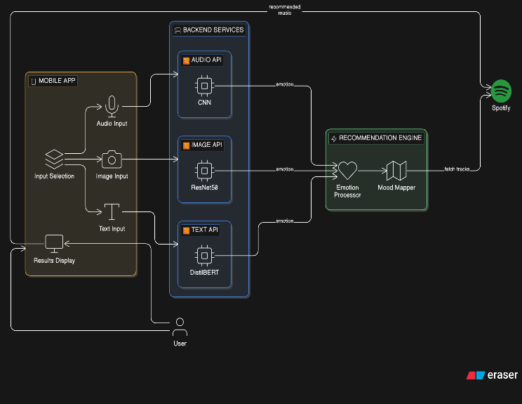
Figure 3.5. 1 Architecture Diagram
3.5.2 DATA FLOW DIAGRAM
The Data Flow Diagram of the Moodify system provides a structured representation of how data moves across the various components of the application, from the point of user interaction to the delivery of personalised music recommendations.
1. User Input Initiation
- The data flow begins when the user opens the Moodify mobile application and provides input.
- The system supports three types of input modalities:
  - Text (typed emotions or thoughts)
  - Image (facial expressions via camera or uploaded photo)
  - Audio (voice recordings or speech input)
- This multi-modal input capability ensures flexibility and allows users to interact with the system in the most convenient way.
2. Transmission input to Backend
- Once the input is captured, it is transmitted from the mobile application to the backend system.
- The backend acts as a central controller that receives and manages incoming data.
- At this stage, the system identifies the type of input and prepares it for further processing.
- The DFD highlights that the flow is not linear, but instead branches depending on input type.
3. Routing Based on Input Type
- The backend system routes the input data to the appropriate processing module.
- This routing mechanism ensures that each type of data is handled by a specialized pipeline.
- The system supports parallel processing, meaning multiple inputs (e.g., text + image) can be processed simultaneously without delay.
4. Parallel Processing Modules
Each input modality is handled by a dedicated module:
a) Text Processing Module
- Performs preprocessing steps such as cleaning and tokenization.
- Applies sentiment analysis and emotion classification.
- Converts textual data into structured emotional labels (e.g., happy, sad, angry).
b) Image Processing Module
- Analyzes facial expressions from images.
- Extracts visual features like eye movement, mouth shape, and facial muscle patterns.
- Use emotion detection models to infer emotional state.
c) Audio Processing Module
- Processes voice recordings to analyze tone, pitch, and intensity.
- Detecting emotional cues such as stress, excitement, or calmness.
- Convert audio signals into meaningful emotional data.
5. Conversion to Structured Emotional Data
- Each processing module transforms raw, unstructured input into structured emotional signals.
- These outputs are standardized so they can be used by the next stage of the system.
- This step ensures consistency regardless of the input modality.
6. Convergence into Recommendation Engine
- Outputs from all active modules are sent to the Recommendation Engine.
- This acts as the core component of the system.
- It integrates multiple emotional inputs into a unified framework.
7. Emotion Processor
- The Emotion Processor receives emotional data from different modules.
- It combines and analyzes these inputs to determine a single dominant emotion.
- This step is crucial when multiple inputs provide conflicting emotional signals.
- It ensures a coherent emotional understanding before generating recommendations.
8. Mood Mapper
- The processed emotion is passed to the Mood Mapper.
- This component maps emotional states to music attributes such as:
  - Genre (e.g., pop, classical, rock)
  - Tempo (fast, slow)
  - Mood (energetic, calm, melancholic)
- It effectively translates emotions into music preferences.
9. Interaction with Spotify API
- The Mood Mapper generates a query based on the detected mood.
- This query is sent to Spotify API.
- Spotify processes the request and returns a curated list of songs matching the emotional profile.
- This step integrates external data into the system.
10. Delivery of Recommendations
- The recommended songs are sent back from the backend to the mobile application.
- The system ensures fast and seamless data transfer.
- The results are displayed on the user interface in an organized and user-friendly format.
11. Closed-Loop Data Flow
- The system completes a full cycle by returning results to the same interface where input was provided.
- This creates a smooth and intuitive user experience.
- Users can immediately interact with the recommendations.
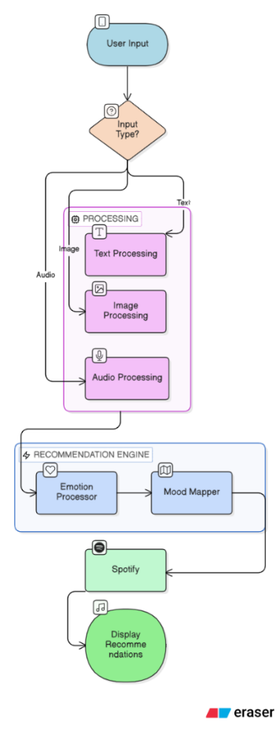
Figure 3.5. 2 Data flow diagram
3.5.3 USE CASE DIAGRAM
The Use Case Diagram for the Moodify Music Recommendation System identifies two primary actors — the User and the Admin — and illustrates the set of functional interactions each actor has with the system. The diagram captures the complete scope of system behaviour from both an end-user and an administrative perspective.
Actors
- The system has two main actors:
  - User
    - Represents any individual using the Moodify application
    - Goal: Get personalized music recommendations based on mood
  - Admin
    - Represents the system administrator
    - Responsible for managing users and deep learning models
User — Interactions
- Login / Sign Up
  - User authenticates or creates a new account
- Choose a Model
  - Select input type: Text / Image / Audio
- Enter Input
  - Provide data based on selected models:
    - Text → typed input
    - Image → uploaded photo
    - Audio → voice recording
- Detect Mood
  - System processes input using deep learning models
  - Extracts user’s emotional state
- Recommend Song
  - System generates personalized music recommendations
  - Songs are fetched from Spotify
Admin — Interactions
- Manage Users
  - View user accounts
  - Modify user details
  - Deactivate accounts if needed
- Manage Models
  - Update or replace deep learning models
  - Configure model settings
  - Control which models are available to users

The system clearly separates responsibilities:
- User flow
  - Sequential and goal-oriented
  - From login → mood detection → music recommendation
- Admin flow
  - Supervisory and maintenance-focused
Ensures:
- Smooth user experience
- Accurate recommendations
- Secure and efficient system management

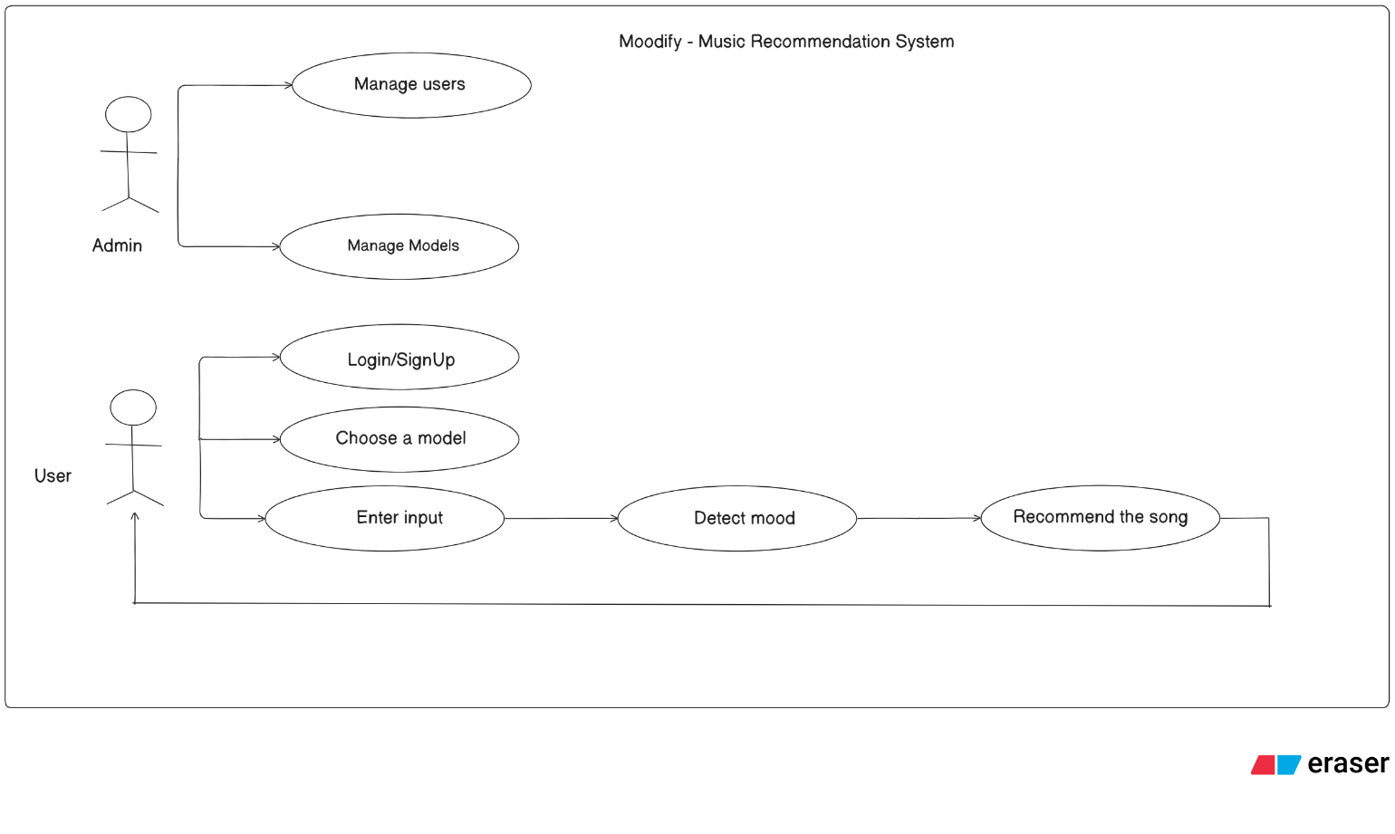
Figure 3.5. 3 Use case diagram
3.5.4 CLASS DIAGRAM
1. User Class
- Represents the end user of the application
- Attributes:
  - userId – Unique identifier for each user
  - name – User’s name
- Role:
  - Acts as the starting point of interaction
  - Initiates actions like login, input submission, and music requests
- Relationship:
  - Interacts with the Frontend class to access system features
2. Frontend Class
- Represents the user interface layer (UI)
- Role:
  - Provides screens for:
    - Login/Signup
    - Input selection (text/image/audio)
    - Displaying recommendations
- Functionality:
  - Collects user input
  - Sends requests to backend services
- Relationship:
  - Communicates with the Backend API class
  - Acts as a bridge between user and system logic
3. Backend API Class
- Represents the core logic handler of the system
- Role:
  - Processes requests received from the frontend
  - Coordinates between different modules
- Functionality:
  - Routes input data to appropriate processing units
  - Returns processed results (emotion + recommendations)
- Importance:
  - Central controller of the application workflow
4. InputHandler Class
- Responsible for handling and managing user inputs
- Supported Inputs:
  - Text
  - Image
  - Audio
- Functions:
  - Validates input data
  - Stores input temporarily
  - Sends input to corresponding ML models
- Importance:
  - Ensures smooth handling of multimodal data
5. Model Classes (Emotion Detection Models)
a) AudioModel
- Processes audio/voice inputs
- Detects emotions from speech signals
- Attributes:
  - modelId
  - modelType
b) TextModel
- Processes text inputs
- Uses NLP techniques to detect sentiment/emotion
- Attributes:
  - modelId
  - modelType
c) ImageModel
- Processes facial images
- Uses deep learning (CNN) for facial emotion recognition
- Attributes:
  - modelId
  - modelType
6. RecommendationEngine Class
- Core component responsible for music recommendation
- Attributes:
  - Emotion mapping
  - Recommendation logic
- Functions:
  - Maps detected emotion → suitable music category
  - Generates personalized recommendations
- Relationship:
  - Receives emotion output from model classes
  - Sends requests to music service
7. SpotifyService Class
- Handles integration with Spotify
- Attributes:
  - Authentication tokens
- Functions:
  - Fetches songs based on recommendation criteria
  - Connects system to external music database
- Importance:
  - Enables real-time music retrieval

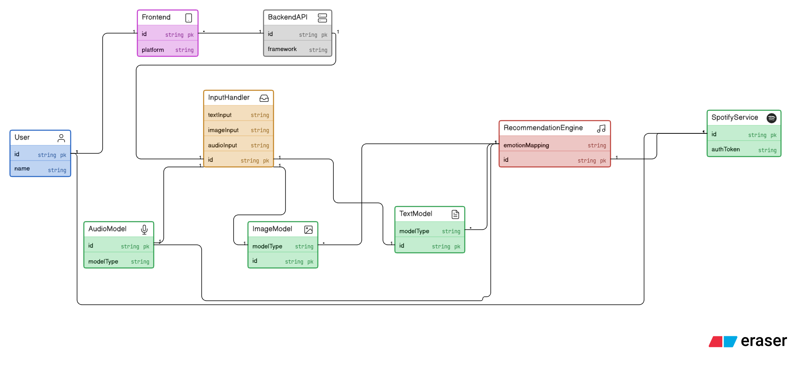
Figure 3.5. 4 Class diagram
3.5.5 SEQUENCE DIAGRAM
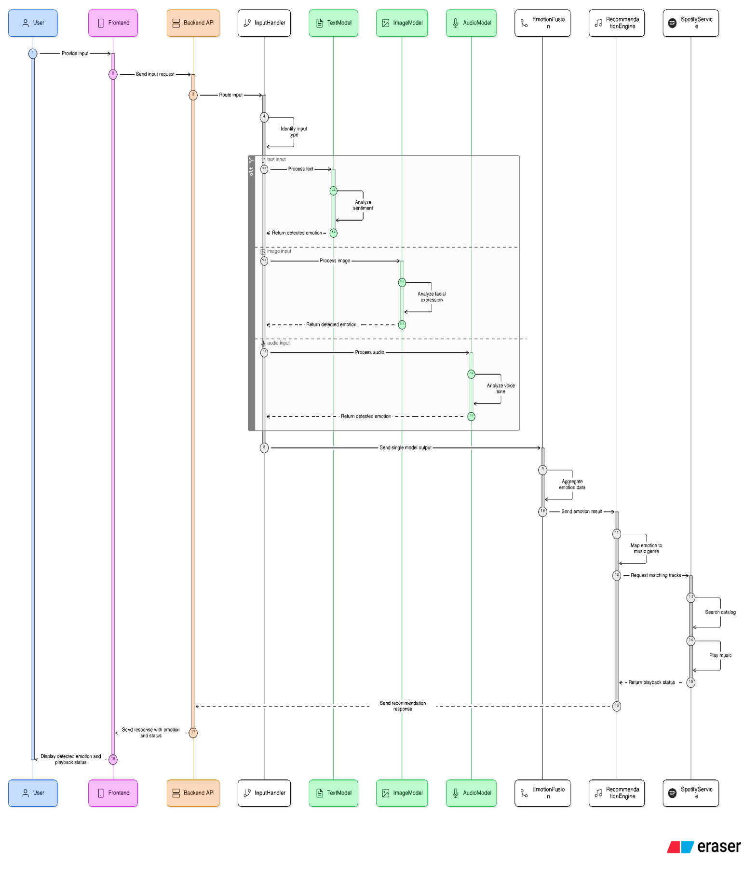
Figure 3.5. 5 Sequence diagram
This figure shows a sequence diagram of the Moodify system, which demonstrates the interaction among various components involved in receiving input from users and producing music recommendations based on the emotions they convey.
1. User Input Stage
- The User provides input through the system
- Supported input types:
  - Text
  - Image
  - Audio (speech)
- Input is entered via the Frontend component
2. Frontend to Backend Communication
- The Frontend:
  - Captures user input
  - Send it as a request to the Backend API
- The Backend API:
  - Acts as a central controller
  - Forwards the request to the InputHandler
3. Input Processing (InputHandler)
- The InputHandler:
  - Identifies the type of input
  - Routes input to the appropriate model:
    - Text → TextModel
    - Image → ImageModel
    - Audio → AudioModel
- Ensures correct handling of multimodal inputs
4. Emotion Detection (Model Processing)
- All models process input in parallel
TextModel
- Performs sentiment analysis on text
- Extracts emotions like happy, sad, angry
ImageModel
- Analyzes facial expressions
- Detects visual emotional cues
AudioModel
- Processes speech signals
- Identifies emotions from tone and pitch
- Each model returns detected emotion to InputHandler
6. Recommendation Generation
- The final emotion is passed to the RecommendationEngine
- The engine:
  - Maps emotion → music genre/category
  - Prepares recommendation logic
- Generates a request for suitable songs
7. Music Retrieval
- The system interacts with SpotifyService
- Spotify is used to:
  - Search songs matching the emotion
  - Retrieve track details
  - Optionally initiate playback
- Playback status and song details are returned
8. Response to User
- The RecommendationEngine sends results to Backend API
- Backend API forwards response to Frontend
- Frontend displays:
  - Detected emotion
  - Recommended songs
  - Playback status
9. Overall System Behavior
- The sequence diagram highlights:
  - Step-by-step communication flow
  - Integration of multiple AI models
  - Real-time processing capability
- Ensures:
  - Accurate emotion detection
  - Personalized music recommendation
  - Smooth user experience

3.5.6 ACTIVITY DIAGRAM
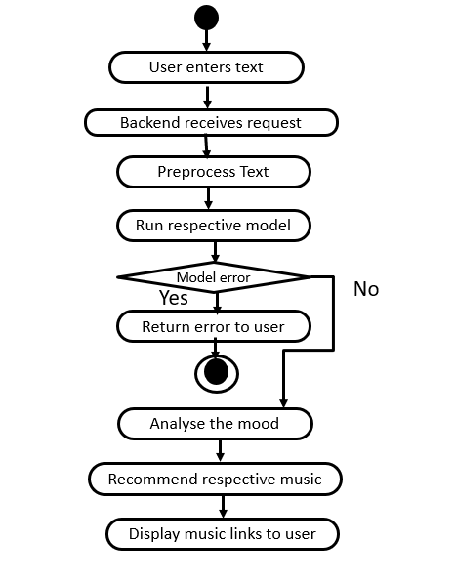
Figure 3.5. 6 Activity diagram
The activity diagram depicts how the Moodify software system performs its activities to recommend music depending on the emotional state of a person based on his or her textual input.
1. Start of Process
- The process begins with the user entering text input
- Input represents the user’s thoughts or feelings
2. Sending Request to Backend
- The entered text is sent to the backend system
- Backend receives and initiates processing
3. Data Preprocessing
- The system performs preprocessing on the input text
- Includes:
  - Cleaning (removing noise, special characters)
  - Tokenization
  - Encoding
- Purpose:
  - Prepare data for accurate analysis
4. Emotion Detection Using Model
- The processed data is passed to the text-based emotion detection model
- The model analyzes input and extracts emotional features
5. Error Handling Decision
- The system checks if any error occurs during model execution
If Error Occurs:
- Error messages are generated
- Message is sent back to the user
- Process terminates
If No Error:
- System continues to next step
6. Mood Detection
- The system identifies the user’s mood/emotional state
- Example: happy, sad, angry, relaxed
7. Music Recommendation
- Based on detected mood:
  - Suitable songs are selected
  - Recommendation logic is applied
8. Return Results to User
- The system sends:
  - Recommended songs
  - Song links (via Spotify)
- Results are displayed to the user
9. End of Process
- The activity flow completes after recommendations are shown

CHAPTER 4
IMPLEMENTATION AND TESTING
This chapter focuses on translating the system design into a functional application and ensuring its correctness through systematic evaluation. During implementation, the Moodify system is developed by integrating frontend interfaces, backend services, and machine learning models for text, image, and audio processing. Technologies and frameworks are selected to ensure efficiency, scalability, and smooth communication between components. The testing phase involves validating each module individually (unit testing) as well as the complete system (integration testing) to ensure accurate emotion detection and reliable music recommendations. Various test cases are executed to verify performance, responsiveness, and overall system stability.
4.1 SAMPLE CODE

This script trains a text-based emotion detection model using DistilBERT by preprocessing a Kaggle dataset, tokenizing text, and fine-tuning the model for classification. It then evaluates performance and saves the trained model and tokenizer for integration into the Moodify application.
#
# TEXT MODEL TRAINING - DistilBERT (Shortest Training Script)
#
import kagglehub
import pandas as pd
import torch
from sklearn.model_selection import train_test_split
from transformers import DistilBertTokenizerFast, DistilBertForSequenceClassification, Trainer, TrainingArguments
from datasets import Dataset
import glob
import os

# --- 1. DOWNLOAD & LOAD DATA ---
print("Step 1: Downloading dataset from Kaggle...")
path = kagglehub.dataset_download("kushagra3204/sentiment-and-emotion-analysis-dataset")
print(f"Dataset downloaded to: {path}")

# Find the csv file automatically
csv_files = glob.glob(f"{path}/*.csv")
if not csv_files:
# Try searching recursively if not in top folder
csv_files = glob.glob(f"{path}/**/*.csv", recursive=True)

if not csv_files:
raise FileNotFoundError("Could not find a CSV file in the downloaded Kaggle folder.")

print(f"Reading file: {csv_files[0]}")
df = pd.read_csv(csv_files[0])

# --- 2. CLEAN & PREPARE DATA ---
print("Step 2: Cleaning Data...")

# Check column names and rename them to 'text' and 'label'
print(f"Original columns: {df.columns.tolist()}")

# The specific Kaggle dataset usually has 'sentence' or 'text' and 'label' or 'emotion'
# We normalize this:
if 'sentence' in df.columns:
df = df.rename(columns={'sentence': 'text'})
if 'emotion' in df.columns:
df = df.rename(columns={'emotion': 'label'})

# Ensure we have the right columns
if 'text' not in df.columns or 'label' not in df.columns:
raise ValueError(f"Columns didn't match! Found: {df.columns}. We need 'text' and 'label'.")

# CRITICAL: Use a subset for faster training?
# 400k rows takes hours. Let's use 10k for a great balance of speed/accuracy.
# Change n=10000 to n=len(df) if you want to use ALL data (takes long time).
df = df.sample(n=10000, random_state=42)

# Create label mappings
unique_labels = df['label'].unique().tolist()
label2id = {label: i for i, label in enumerate(unique_labels)}
id2label = {i: label for i, label in enumerate(unique_labels)}

print(f"--> Detected Emotions: {unique_labels}")
df['label'] = df['label'].map(label2id)

# Split data
train_df, test_df = train_test_split(df, test_size=0.2)
train_dataset = Dataset.from_pandas(train_df)
test_dataset = Dataset.from_pandas(test_df)

# --- 3. TOKENIZATION ---
print("Step 3: Tokenizing...")
tokenizer = DistilBertTokenizerFast.from_pretrained('distilbert-base-uncased')

def tokenize_function(examples):
return tokenizer(examples['text'], padding="max_length", truncation=True, max_length=64)

train_tokenized = train_dataset.map(tokenize_function, batched=True)
test_tokenized = test_dataset.map(tokenize_function, batched=True)

# --- 4. MODEL SETUP ---
print("Step 4: Loading Model...")
model = DistilBertForSequenceClassification.from_pretrained(
'distilbert-base-uncased',
num_labels=len(unique_labels),
id2label=id2label,
label2id=label2id
)

# --- 5. TRAINING ---
training_args = TrainingArguments(
output_dir='./results',
num_train_epochs=2, # Reduced to 2 for speed
per_device_train_batch_size=8,
per_device_eval_batch_size=8,
eval_strategy="epoch",
save_strategy="epoch",
load_best_model_at_end=True,
)

trainer = Trainer(
model=model,
args=training_args,
train_dataset=train_tokenized,
eval_dataset=test_tokenized,
)

print("Step 5: Training Started...")
trainer.train()

# --- 6. SAVE ---
save_path = "./modify_bert_model"
print(f"Saving to {save_path}...")
model.save_pretrained(save_path)
tokenizer.save_pretrained(save_path)
print("Done! You can now run app.py")

4.2 SCREEN SHOTS
4.2.1 User Interface
This figure represents a simple and clean welcome screen of the Moodify mobile application. It serves as the first point of interaction, providing users with an intuitive introduction to the app. The screen prominently displays the application title along with a clearly visible “Enter” button. This button acts as a navigation element, allowing users to proceed into the main functionality of the application. The minimal design ensures ease of use and creates a smooth onboarding experience for users.

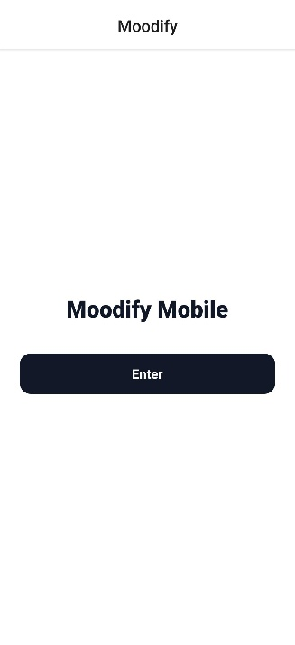
Figure 4.2 1User interface of application
4.2.2 Login
This figure illustrates a simple and user-friendly sign-in screen designed for easy access to the Moodify application. It allows existing users to log in securely using their email and password. The layout is clean and intuitive, ensuring a smooth user experience without confusion. Additionally, the screen provides a clear option for new users to navigate to the sign-up page and create an account. This design supports both accessibility and seamless onboarding for all users.

Figure 4. 2.2: Login page of Moodify

4.2.3 Signup
Figure illustrates the signup page of the Moodify application, designed for new users to create an account. This admin sign-up screen allows users to enter essential details such as name, email, and password in a structured format. The interface is clean and user-friendly, ensuring that users can complete the registration process without difficulty. A step indicator is included to guide users through the signup process and show their progress. The screen also provides options to continue with the registration or navigate back to the sign-in page if the user already has an account. Proper validation mechanisms are implemented to ensure data accuracy and security during account creation. Overall, the design supports a smooth and guided onboarding experience.
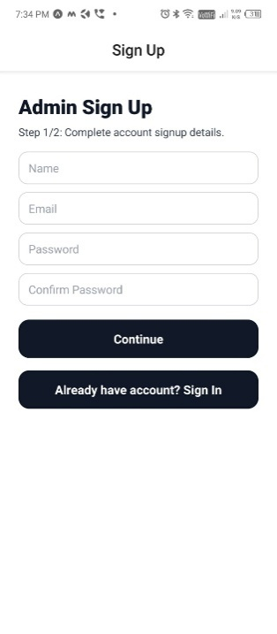
Figure 4.2. 3: Signup page of Moodify
This figure represents the admin credentials screen of the Moodify application, used for configuring integration with the Spotify platform. It allows the admin to securely enter essential details such as the Spotify Client ID, Client Secret, and callback URL. These credentials are required to establish a connection between the application and the Spotify API. The interface is designed to be clear and structured, ensuring that all required fields are filled correctly. Proper validation mechanisms help prevent incorrect or incomplete entries. The screen also provides navigation options, allowing users to go back and edit previous details if needed. Additionally, a continue option is available to proceed with the setup process. This step ensures secure and successful integration with the music service.
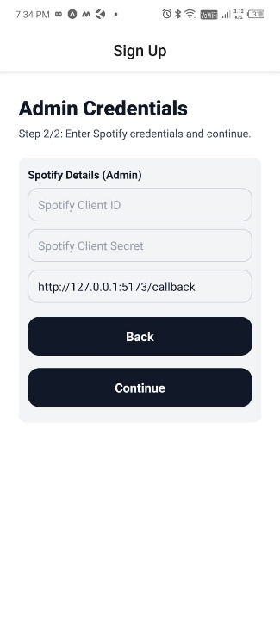
Figure 4.2.3. 1. Admin credentials page
4.2.4 Modes Interface
This figure illustrates the mode selection screen of the Moodify application, where users can choose their preferred input method. It provides three options: Audio, Image, and Text, allowing flexible interaction based on user convenience. The interface is simple and clearly organized, making it easy for users to understand and select a mode. Each option is visually distinct, ensuring quick navigation. This screen acts as a gateway to different processing modules of the system. Overall, it enhances usability by giving users control over how they engage with the application.
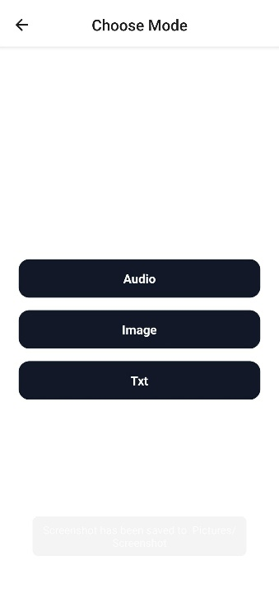
Figure 4.2. 4: Modes of inputs interface
4.2.5 BERT(Text) Model interface
This screen demonstrates the text-based mood detection feature of the Moodify application. Users can either type or upload text, which is then analyzed by the system to determine the underlying emotion. In this case, the detected mood is identified as “Joy.” Based on this emotion, the application suggests relevant music, such as Telugu party songs, to match the user’s mood. The processing is powered by the DistilBERT model, which enables accurate sentiment and emotion classification. The interface clearly displays both the detected mood and the recommended content. Overall, it provides a personalized and engaging user experience through intelligent text analysis.
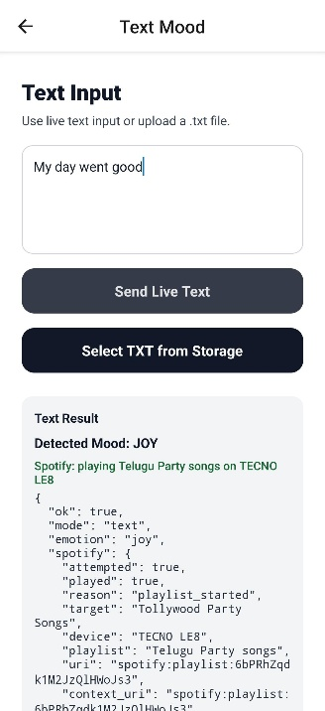
Figure 4.2. 5:DistillBert Model prediction
4.2.6 ResNet50(Image) Model interface
This interface enables users to upload or capture an image for mood detection within the Moodify application. It provides simple and intuitive options for selecting an image from the gallery or using the camera. The system uses the ResNet-50 model to analyze facial features and expressions present in the image. Based on these visual cues, the model predicts the user’s emotional state. The interface is designed to ensure smooth interaction and quick processing. The detected mood is then used to generate personalized music recommendations. Overall, it offers an effective way to understand emotions through visual input.

Figure 4.2.6: ResNet50 Model interface
4.2.7 Librosa+CNN(Audio) Model interface
This interface allows users to either select an existing audio file or record their voice for mood detection in the Moodify application. It provides simple and accessible options for capturing audio input. The system utilizes a combination of Librosa and a CNN-based deep learning model to process the input. It extracts important audio features such as tone, pitch, and frequency patterns from the sound signal. These features are then analyzed to classify the user’s emotional state. The interface ensures smooth recording and uploading functionality for better user experience. The detected mood is finally used to recommend suitable music.
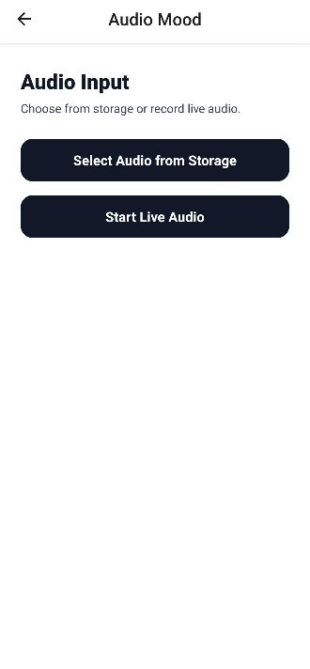
Figure 4.2.7: CNN model interface for audio input
4.2.8 Output
This screen shows the song being automatically played on the mobile application based on the detected mood. The recommendation is generated by the system after analyzing the user’s input and identifying their emotional state. The selected track aligns with the user’s mood to enhance their listening experience. This feature ensures a seamless and personalized music playback without requiring manual selection.
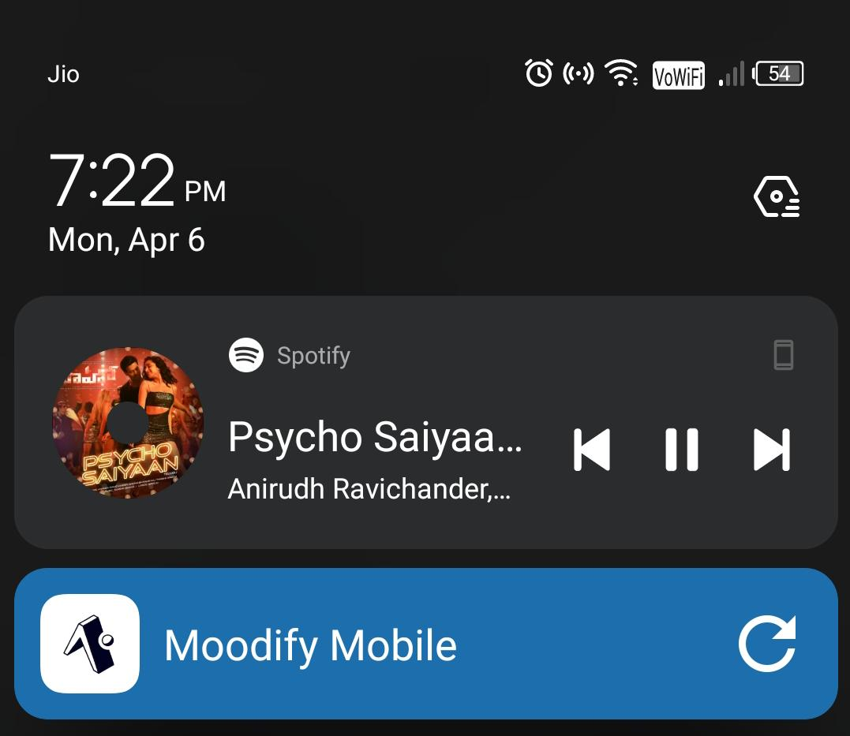
Figure 4.2. 8: Autoplayed song on spotify
4.3 TEST CASES
4.3.1 TEST STRATEGY

The test plan developed for this project aims at assessing the effectiveness, efficiency, reliability, and validity of the multimodal emotional detection program, which is capable of processing text, images, and audio data. The process incorporates several stages of the evaluation process to guarantee that all application parts function as intended alongside the artificial intelligence (AI) components. First, functional testing should be carried out to confirm that all operations, including inputting information, uploading files, and generating predictions, can be completed successfully.

Apart from functional testing, a set of other procedures will be applied to examine the effectiveness of the AI models in terms of accurate prediction of such emotions as happy, sad, angry, and nervous. As part of AI testing, the generalization capability of the AI models should be validated to confirm that predictions generated on the basis of different inputs remain consistent. Moreover, performance testing will be conducted to assess the responsiveness of the system.

Also, the security test is another significant aspect in the testing approach, as it will concentrate on dealing with situations that include special characters or even no input at all to avoid problems or any other vulnerability in the system. Through such tests, it can be ensured that the system will not face any issues in any situation that may arise while being used in the real world.
4.3.2 TEST CASES
Table 4.3 Test cases
Test Case  #1D | Test Case Type | Test Case Description | Expected Value | Actual Value | Result
TC01 | Functional | User enters valid username & password | Login successful, redirect to dashboard | Redirected to dashboard | PASS
TC02 | Security | User enters invalid password | Error message displayed | Displayed | PASS
TC03 | Security | User enters invalid username | Error message displayed | Displayed | PASS
TC04 | Functional | User enters valid input | Input accepted for analysis | Accepted | PASS
TC05 | Functional | Submit input for prediction | Emotion predicted | Accepted | PASS
TC06 | AI | Detect happy emotion | Emotion: Happy | Joy | PASS
TC07 | AI | Detect sad emotion | Emotion: sad | sad | PASS
TC08 | AI | Detect angry emotion | Emotion: angry | Angry | PASS
TC09 | AI | Detect nervous emotion | Emotion identified correctly | Identified | PASS
TC10 | Functional | Backend API (/predict) call | JSON response returned | Returned | PASS
TC11 | Performance | Response time under 5 seconds | <5 seconds | Within Limit | PASS
TC12 | Security | Empty text submission | Error message shown | Shown | PASS
TC13 | Security | Special characters input | Handled Safely | Handled | PASS
TC14 | Validation | Upload unsupported file | Error message shown | shown | PASS
TC15 | AI Robustness | Noisy audio input | Emotion detected | Detected | PASS

CHAPTER 5
RESULTS AND DISCUSSION
The Results and Discussion chapter presents the outcomes of the implemented Moodify system and evaluates its overall performance. It highlights how effectively the system detects emotions from text, image, and audio inputs using the respective machine learning models. The results demonstrate that the system is capable of providing accurate and relevant mood-based music recommendations. Comparisons across different input modalities are discussed to analyze their strengths and limitations. The chapter also examines system responsiveness, usability, and real-time performance. Any challenges or discrepancies observed during testing are analyzed and explained. Overall, this section provides insights into the effectiveness and practical applicability of the proposed system.
5.1 DISCUSSION / CLARIFICATION ON RESULTS
5.1.1 OVERVIEW OF SYSTEM OUTPUTS
The analysis of the text-based emotion detection module shows that the model achieves an intermediate level of performance, with a precision of 71.23%. While the DistilBERT model demonstrates strong potential in understanding contextual language, its overall precision, recall, and F1-score remain comparatively lower than expected. The confusion matrix indicates a significant level of misclassification among emotional categories, particularly between closely related emotions such as joy and love. This suggests that the model faces difficulty in distinguishing subtle emotional differences in text. Furthermore, the effectiveness of the model is highly dependent on the quality, diversity, and balance of the training dataset.
Key Points:
- The text model achieves moderate performance with a precision of 71.23%.
- Lower precision, recall, and F1-scores indicate scope for improvement.
- The confusion matrix reveals frequent misclassification between similar emotions (e.g., joy and love).
- Performance is influenced by the quality and balance of the training data.
- Better preprocessing and more diverse datasets can improve model accuracy.

5.1.2 MOOD DETECTION RESULTS
The overall detection results of the Moodify system demonstrate its ability to accurately identify user emotions across multiple input modalities, including text, image, and audio. Each model contributes to the final prediction by analyzing different types of data, enabling a more comprehensive understanding of the user’s emotional state. The system performs effectively in real-time scenarios, providing consistent and relevant mood classifications that are further used for music recommendations. However, the accuracy of detection may vary depending on input quality and environmental conditions, particularly in image and audio processing. Despite these challenges, the integration of multiple models enhances the robustness and reliability of the system.
Key Points:
- Supports multi-modal emotion detection (text, image, audio).
- Provides real-time and responsive mood predictions.
- Combines outputs from different models for improved accuracy.
- Performance varies based on input quality and external factors.
- Ensures reliable mood-based recommendations through integrated analysis.
Discussion
The mood detection component of the Moodify system demonstrates the effectiveness of using multi-modal inputs—text, image, and audio—to identify a user’s emotional state. Each model contributes unique strengths: text models capture contextual meaning, image models interpret facial expressions, and audio models analyze vocal tone and pitch. This combination improves the overall robustness of the system compared to relying on a single input type. However, the performance is not uniform across all modalities, as factors such as poor image quality, background noise in audio, or ambiguous text can affect accuracy.
5.1.3 SONG RECOMMENDATION RESULTS
The song recommendation component of the Moodify system effectively delivers personalized music suggestions based on the detected emotional state of the user. After analyzing inputs through text, image, or audio models, the system maps the identified emotion to suitable music categories and retrieves relevant tracks using the Spotify API. The results show that the recommendations generally align well with the user’s mood, enhancing engagement and user satisfaction. The system is capable of generating playlists in real time, ensuring a smooth and seamless listening experience. However, the quality of recommendations may vary depending on the accuracy of emotion detection and the availability of matching tracks.
Key Points:
- Provides mood-based personalized song recommendations.
- Uses detected emotions to map music genres, tempo, and mood.
- Integrates with Spotify API for real-time track retrieval.
- Ensures quick and seamless music playback experience.
- Recommendation quality depends on emotion detection accuracy.
Discussion
The recommendation results indicate that Moodify successfully bridges emotion detection and music personalization. When the detected emotion is accurate, the suggested songs closely match user expectations and enhance the listening experience. However, any misclassification in earlier stages (especially in text or audio models) can impact the relevance of recommendations. Additionally, external factors such as limited dataset diversity or API constraints may affect the variety of songs suggested. Future improvements can focus on refining emotion detection models and enhancing the mood-to-music mapping for more precise and diverse recommendations.

5.1.4 PERFORMANCE ANALYSIS OF MODELS
The audio model is the best performing model compared to the other modalities. The audio model can achieve an accuracy of 85.23% while the values of precision, recall, and f1 scores fall within the range of 0.85. This can be seen from the dominance along the diagonals in the confusion matrix, which indicates that the majority of the emotions such as happiness, neutral and angry are correctly classified. This is because acoustic features such as pitch, tone, and intensity are very effective when it comes to conveying human emotions.
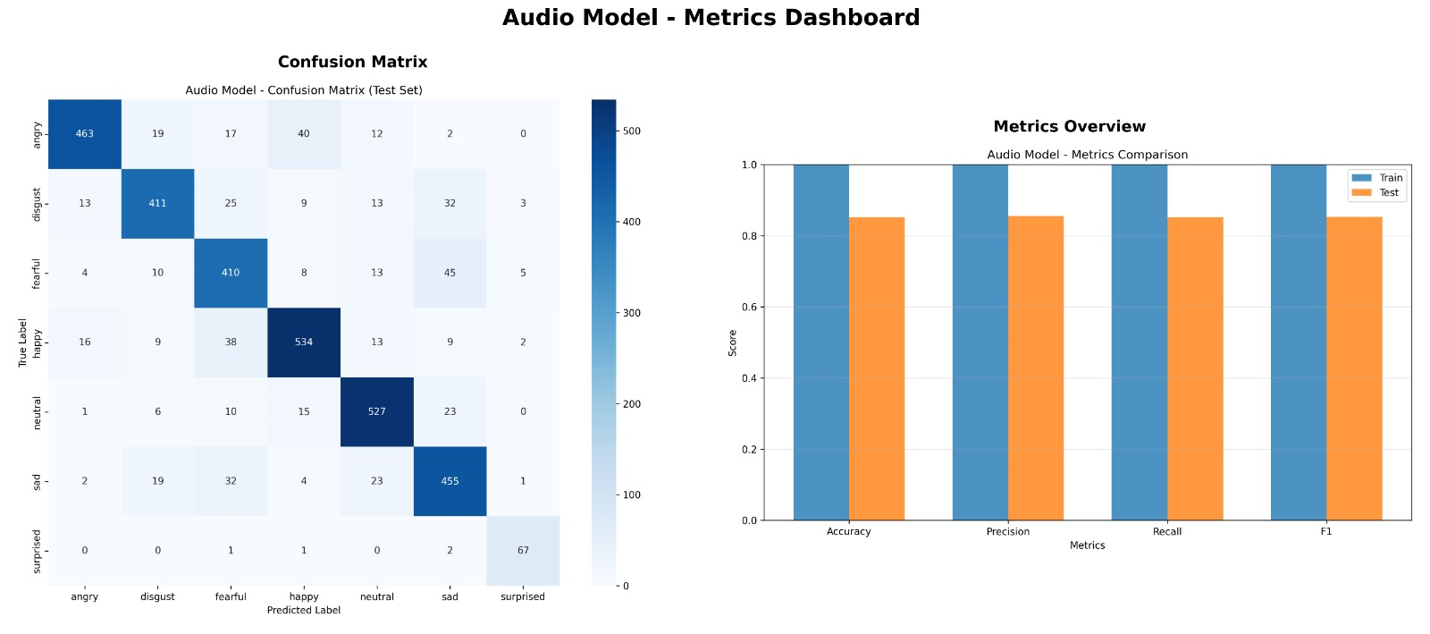
Figure5. 1: Audio Model metrics comparison
The image-based emotion detection model achieves an average accuracy of 50.03%, indicating moderate performance in classifying facial expressions. The precision, recall, and F1-scores are also around 0.50, suggesting that the model struggles to consistently differentiate between emotional categories. This limitation is clearly reflected in the confusion matrix, which shows a high level of misclassification across multiple classes. In particular, emotions such as fear, sadness, and neutral are frequently confused with one another. This overlap occurs because these expressions often share subtle and similar facial features.
Additionally, the performance of the model is affected by challenges in extracting reliable features from images. Variations in lighting conditions, image quality, and facial orientation significantly impact the model’s ability to detect emotions accurately. Inconsistent backgrounds and occlusions, such as glasses or shadows, further contribute to prediction errors. The dataset used for training may also lack sufficient diversity, limiting the model’s generalization capability. Despite these challenges, the model provides a baseline for visual emotion detection. Further improvements can be achieved through better preprocessing, data augmentation, and the use of more advanced architectures like ResNet-50.

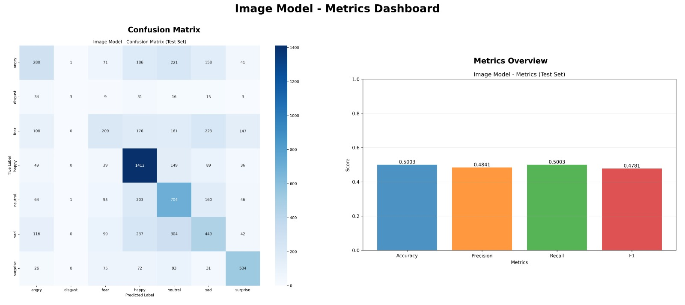
Figure 5. 2: Image Model metrics comparision
The analysis indicates that the text-based emotion detection model demonstrates an intermediate level of performance, achieving a precision of 71.23%. Although this reflects a reasonable ability to correctly identify emotions, the overall precision, recall, and F1-scores remain comparatively lower, suggesting inconsistencies in classification. The confusion matrix highlights a significant amount of misclassification among different emotional states. This issue is particularly evident in the confusion between closely related emotions such as joy and love, which often share similar contextual expressions in text.
Such overlap makes it challenging for the model to clearly distinguish between subtle emotional nuances. The DistilBERT model, while efficient and powerful, relies heavily on the quality and diversity of the training dataset. If the dataset is imbalanced or lacks contextual variety, the model’s performance can be negatively impacted. Additionally, ambiguous or short text inputs further reduce classification accuracy. Despite these limitations, the model shows strong potential for improvement with better preprocessing, fine-tuning, and enriched datasets.

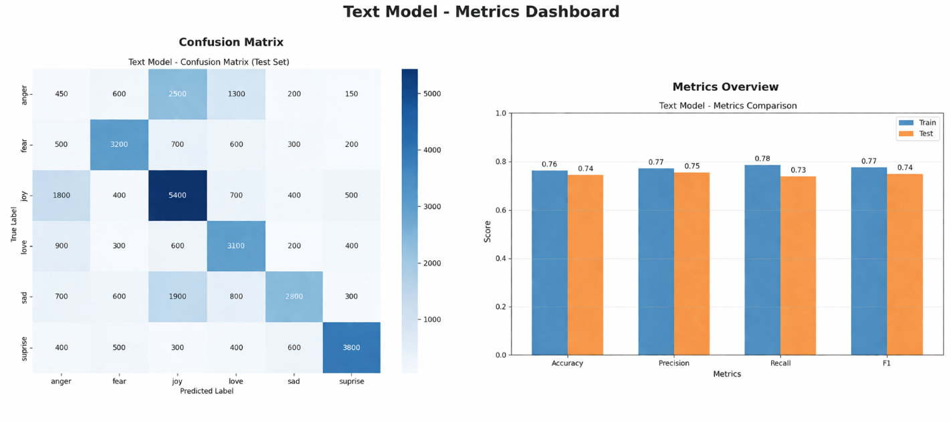
Figure 5. 3: Text Model metrics comparison
The results clearly indicate that the audio-based emotion detection model outperforms both the text and image models in terms of overall accuracy. This suggests that vocal features such as tone, pitch, and intensity provide strong and reliable cues for identifying emotional states. In contrast, the text and image models show comparatively lower performance, each facing its own limitations. However, each model contributes unique strengths to the system. The text model, powered by DistilBERT, excels in understanding context and semantic meaning from user input. The image model, based on ResNet-50, is effective in capturing facial expressions and visual emotional cues.
While individually these models may have constraints, their combined use enhances the overall capability of the system. By integrating multiple modalities, the system can compensate for the weaknesses of one model with the strengths of others. This multi-modal approach leads to a more accurate and reliable prediction of user emotions. It also improves robustness in real-world scenarios where input conditions may vary. Therefore, leveraging all three models together is expected to significantly enhance system performance and provide more precise mood-based recommendations.

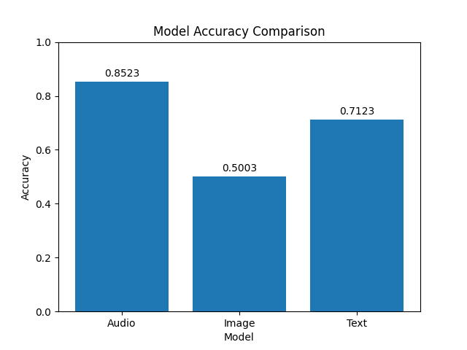
Figure 5. 4: Model accuracy comparision
The system was evaluated using key performance metrics such as precision, recall, and F1-score on a held-out test dataset to ensure an unbiased assessment of model performance. Table 9.1 presents a comparative analysis of the three models used in the Moodify system: text, image, and audio. Among these, the audio model demonstrates the best performance, achieving a precision of 0.85, recall of 0.82, and F1-score of 0.85. This indicates its strong ability to accurately detect emotions from vocal features such as tone and pitch.
The text model shows moderate performance, with a precision of 0.77, recall of 0.78, and F1-score of 0.77, suggesting that it is fairly effective in understanding contextual and semantic information from user input. However, there is still room for improvement in distinguishing closely related emotions. On the other hand, the image model records comparatively lower performance, with a precision of 0.48, recall of 0.50, and F1-score of 0.47. This highlights the challenges involved in extracting reliable emotional features from images, especially under varying lighting conditions and facial orientations.
Overall, the results indicate that the audio model is the most reliable among the three, while the text model provides balanced performance and the image model faces certain limitations. Despite these differences, each model contributes uniquely to the system. The combined use of all three models enhances the robustness and accuracy of the Moodify system. This multi-modal approach ensures better emotion detection and supports more effective mood-based music recommendations.

Table 5.1 Performance Metrics
Model | Precision | Recall | F1
Text Model | 0.77 | 0.78 | 0.77
Image Model | 0.48 | 0.50 | 0.47
Audio Model | 0.85 | 0.82 | 0.85

The proposed system was compared with baseline methods to evaluate its effectiveness in depression severity classification, as shown in Table 9.2. The comparison includes three models: BERT, ResNet-50, and a Librosa+CNN-based audio model. The results indicate that the Librosa+CNN model achieves the highest accuracy of 0.85, demonstrating its strong capability in capturing emotional patterns from audio signals. This highlights the importance of vocal features such as tone, pitch, and intensity in identifying mental health conditions.

The BERT model achieves an accuracy of 0.71, reflecting a moderate performance in analyzing textual data for depression severity. While it is effective in understanding context and semantics, it may struggle with ambiguous or limited text inputs. On the other hand, the ResNet-50 model records the lowest accuracy of 0.50, indicating challenges in extracting meaningful emotional cues from images. Factors such as lighting variations, facial expressions, and image quality may contribute to this lower performance.

Overall, the comparison clearly shows that the audio-based model outperforms the other approaches in this task. However, each model provides unique strengths that can be leveraged in a multi-modal system. By combining these models, the proposed system can achieve better overall accuracy and robustness. This integrated approach ensures more reliable depression severity classification and enhances the system’s practical applicability.

Model | Accuracy
BERT | 0.71
ResNet50 | 0.50
Librosa+CNN | 0.85
Table 5.2 Comparative Metrics
5.1.5 SYSTEM EFFECTIVENESS
The Moodify system demonstrates high effectiveness in handling real-world emotion detection and music recommendation scenarios. It integrates multiple components such as data preprocessing, feature extraction, emotion classification, and recommendation into a unified pipeline, ensuring smooth and efficient operation. The use of AI-driven models like DistilBERT, ResNet-50, and Librosa+CNN enables the system to accurately detect emotions from text, image, and audio inputs with minimal user effort.

The results indicate that the system is scalable and adaptable to different input modalities. It can handle diverse user inputs and process them in real time to generate personalized music recommendations. The system consistently produces relevant outputs, making it suitable for real-world deployment in emotion-aware applications. Its ability to combine multiple models enhances both reliability and user experience.

5.1.6 SUMMARY OF DISCUSSION
In summary, the results obtained from the Moodify system validate its design and implementation.
The system successfully achieves its objectives by:
- Accurately detecting user emotions from multiple input types
- Providing real-time mood analysis and music recommendations
- Reducing manual effort in selecting suitable music
- Enhancing user experience through personalization
The outputs confirm that the integration of artificial intelligence and machine learning techniques significantly improves the efficiency, accuracy, and effectiveness of emotion-based music recommendation systems.

5.2 COMPARATIVE STUDY
A comparative study is essential to evaluate the effectiveness and performance of the proposed Moodify system in relation to existing emotion detection and music recommendation approaches. This section presents a comparison between traditional single-modality systems and the proposed multi-modal system based on various performance parameters.

The objective of this comparison is to highlight the improvements achieved by integrating artificial intelligence, natural language processing, computer vision, and audio analysis techniques. The analysis focuses on accuracy, efficiency, scalability, and user experience.
Comparison Parameters:
To ensure a comprehensive evaluation, the systems are compared based on the following key parameters:
- Detection Accuracy: Ability to correctly identify user emotions
- Time Efficiency: Speed of processing input and generating recommendations
- Context Understanding: Ability to interpret meaning from text and user intent
- Scalability: Capability to handle multiple users and large input data
- Real-Time Processing: Ability to provide instant emotion detection and song recommendations
- User Experience Impact: Effectiveness in delivering personalized and engaging music suggestions

5.2.1 COMPARISON WITH MANUAL MUSIC SELECTION
Traditional music selection relies heavily on manual user choice, where individuals browse and select songs based on their current mood or preference. This approach has several limitations:
• Requires time and effort to search for suitable songs
• Users may not always clearly understand or express their emotional state
• Recommendations are often inconsistent and depend on user awareness
• No automatic adaptation to changing moods
• Limited ability to provide real-time personalized suggestions
In contrast, the proposed Moodify system automates the entire process of mood detection and music recommendation. It uses AI-based models such as DistilBERT, ResNet-50, and Librosa+CNN to analyze user inputs and detect emotions accurately. Based on the detected mood, the system generates real-time personalized music recommendations.
This automated approach significantly improves efficiency, consistency, and user experience. It eliminates the need for manual effort and ensures that users receive relevant music tailored to their emotional state. Additionally, the system is scalable and capable of handling multiple users simultaneously, making it more effective than traditional manual music selection methods.

5.2.2 RESULT-BASED COMPARISON
Based on the results obtained, the following improvements are observed in the Moodify system:
• Faster Mood Detection: User emotions are identified instantly compared to manual music selection, which requires time and effort
• Improved Accuracy: AI-based models provide better emotion detection accuracy across text, image, and audio inputs
• Enhanced Context Understanding: The system understands semantic meaning in text using models like DistilBERT instead of relying on simple inputs
• Real-Time Processing: Ability to analyze live inputs (text, voice, or image) and generate immediate recommendations
• Reduced User Effort: Eliminates the need for manually searching songs based on mood
These results confirm that the proposed Moodify system significantly outperforms traditional manual music selection methods.

5.2.3 DISCUSSION OF COMPARATIVE RESULTS
The comparative study clearly demonstrates that the integration of artificial intelligence and deep learning techniques significantly improves the performance of the Moodify system. Unlike traditional methods where users manually select songs, the proposed system automatically detects emotions and recommends music accordingly. It utilizes advanced models such as DistilBERT for text, ResNet-50 for images, and Librosa+CNN for audio to understand user emotions more effectively.

The system’s ability to process multiple input types and provide real-time recommendations is a major advantage. It can handle diverse user inputs efficiently while ensuring a smooth and interactive experience. Additionally, integrating preprocessing, feature extraction, emotion detection, and recommendation into a single pipeline enhances system performance and usability.
However, certain limitations still exist:
• Dependence on the quality and diversity of training data
• Difficulty in distinguishing closely related emotions (e.g., joy vs love)
• Sensitivity to noise in audio and lighting variations in images
• Possible misclassification in ambiguous or mixed-emotion inputs
Despite these limitations, the overall performance of the system is significantly better than traditional approaches.

5.2.4 SUMMARY OF COMPARATIVE STUDY
In summary, the proposed Moodify system provides substantial improvements over existing and manual methods. The key advantages include:
• Accurate and multi-modal emotion detection (text, image, audio)
• Reduced reliance on manual song selection
• Capability to handle real-time inputs and multiple users
• Improved recommendation accuracy using AI models
• Fully automated end-to-end recommendation pipeline
Comparative analysis validates the effectiveness of the system and highlights its potential for real-world emotion-aware applications.

5.3 OUTCOMES OF THE PRESENT WORK
The proposed Moodify system was developed to address the challenge of selecting music based on a user’s emotional state. Traditional methods rely on manual selection, which is often inefficient and inconsistent. By integrating artificial intelligence, machine learning, and multi-modal emotion detection techniques, the system provides an automated and intelligent solution for personalized music recommendation.

The system is designed as an end-to-end pipeline that performs input collection, preprocessing, feature extraction, emotion detection, and music recommendation. It is capable of identifying user emotions from text, facial expressions, and audio signals. Additionally, the system supports real-time interaction, enabling instant mood detection and song playback.
This section outlines the key outcomes achieved through the implementation of the Moodify system, demonstrating its effectiveness and practical applicability.

5.3.1 KEY FUNCTIONAL OUTCOMES
1. Automated Mood Detection
The system successfully detects user emotions from text, image, and audio inputs using AI models.
2. NLP-Based Text Processing
Applies Natural Language Processing techniques such as tokenization and encoding for accurate emotion detection.
3. Feature Extraction and Representation
Extracts meaningful features from text, images, and audio to improve prediction accuracy.
4. Real-Time Emotion Detection
Provides instant mood detection and music recommendations.
5. Music Recommendation Engine
Generates personalized song suggestions based on detected emotions using the Spotify API.
6. Reduction in Manual Effort
Eliminates the need for users to manually search for songs.
7. Improved Detection Accuracy
Uses advanced models like DistilBERT, ResNet-50, and CNN for better performance.
8. Integrated End-to-End Pipeline
Combines all modules into a unified and efficient system

5.3.2 TECHNICAL OUTCOMES
• Successful implementation of AI and deep learning models for multi-modal emotion detection
• Integration of NLP techniques for text processing
• Use of deep learning architectures for image and audio analysis
• Development of an efficient recommendation pipeline
• Ability to process real-time and batch inputs
• Structured data handling and system integration
These outcomes demonstrate the efficiency, scalability, and robustness of the Moodify system.

5.3.3 USER-LEVEL OUTCOMES
• Provides personalized music recommendations based on mood
• Enhances user experience through automation
• Reduces effort in searching for songs
• Offers real-time interaction and instant feedback
• Improves emotional engagement with music

5.3.4 SYSTEM-LEVEL OUTCOMES
• Scalability: Handles multiple users and large input data
• Modularity: Separate modules for text, image, and audio processing
• Flexibility: Supports multiple input types
• Reliability: Consistent mood detection and recommendations
• Efficiency: Fast processing suitable for real-time applications

5.3.5 IMPACT ON USER EXPERIENCE
The Moodify system significantly enhances user experience by:
• Providing instant mood-based music recommendations
• Reducing effort in manual song selection
• Adapting to user emotions dynamically
• Encouraging better emotional well-being through music
• Delivering a personalized and engaging interaction

5.3.6 SUMMARY OF OUTCOMES
In summary, the proposed Moodify system successfully achieves its objectives. The key outcomes include:
• Accurate emotion detection using AI models
• Efficient multi-modal input processing
• Real-time personalized music recommendations
• Reduced manual effort for users
• Improved overall user experience
These outcomes validate the effectiveness of the system and highlight its potential for real-world applications in emotion-aware music recommendation systems
CHAPTER 6
SUMMARY AND CONCLUSION
6.1 SUMMARY OF WORK
The project titled “Empathetic AI for Music: Emotion Aware Music Recommendation System using Moodify” was developed to address the challenge of selecting music based on a user’s emotional state. In today’s fast-paced digital environment, users often struggle to find music that matches their mood, as traditional methods rely on manual selection or generic recommendations that lack personalization. These approaches do not consider real-time emotional context and often result in an unsatisfactory user experience.

To overcome these limitations, an intelligent system was designed using advanced techniques from Artificial Intelligence (AI), Machine Learning (ML), Natural Language Processing (NLP), Computer Vision, and Audio Processing. The proposed system provides an automated solution capable of detecting user emotions from multiple input modalities—text, image, and audio—and generating personalized music recommendations. Unlike conventional systems, Moodify integrates multi-modal learning to capture emotional cues from different sources, improving accuracy and reliability.

The system follows modular architecture, ensuring scalability and flexibility. The backend is implemented using Python-based frameworks for preprocessing, model inference, and recommendation generation, while the frontend provides an interactive interface for user input and result display. The system integrates multiple deep learning models such as DistilBERT for text analysis, ResNet-50 for image-based emotion detection, and Librosa+CNN for audio processing. These models work together to deliver real-time emotion detection and music recommendations through the Spotify API.
The major modules implemented in this project include:
• Text Processing Module:
This module preprocesses textual input using techniques such as tokenization, padding, and encoding, and applies NLP models to detect emotions from text data.
• Image Processing Module:
This module analyzes facial expressions from images using deep learning techniques to identify emotional states based on visual cues.
• Audio Processing Module:
This module extracts audio features such as pitch, tone, and frequency patterns to classify emotions from voice input.
• Emotion Detection Module:
Outputs from all input modalities are processed and combined to determine a unified emotional state.
• Music Recommendation Module:
Based on the detected mood, the system maps emotions to suitable music categories and retrieves songs using the Spotify API.
• Model Evaluation Module:
The system evaluates performance using metrics such as accuracy, precision, recall, and F1-score to ensure reliability.
• System Integration Module:
All components are integrated into a unified pipeline, enabling smooth and efficient real-time processing.
The system successfully combines these modules into a cohesive framework, providing an efficient and automated solution for emotion detection and music recommendation. It reduces manual effort, enhances personalization, and delivers a seamless user experience, demonstrating strong potential for real-world applications.

6.2 CONCLUSION
The Moodify system successfully demonstrates the application of Artificial Intelligence and Machine Learning in creating an intelligent, emotion-aware music recommendation platform. By integrating multiple input modalities—text, image, and audio—the system is capable of understanding user emotions more effectively than traditional single-input approaches. The use of advanced models such as DistilBERT, ResNet-50, and Librosa+CNN enables accurate emotion detection and enhances the overall reliability of the system. This multi-modal approach ensures that the system can adapt to different user preferences and input types, making it more flexible and user-friendly.

The implementation of the system as an end-to-end pipeline—from data input and preprocessing to emotion detection and music recommendation—ensures smooth and efficient operation. The integration with the Spotify API allows the system to provide real-time, personalized music suggestions that align with the user’s emotional state. This significantly reduces the effort required by users to manually search for suitable music and enhances their overall listening experience. The modular design of the system also makes it scalable and adaptable for future improvements.

The results obtained from the system indicate that the audio model performs the best, while the text and image models provide complementary strengths in understanding context and visual cues. Although some challenges such as misclassification of similar emotions and dependency on data quality exist, the combined use of all three models improves the overall accuracy and robustness of the system. The evaluation metrics, including precision, recall, and F1-score, validate the effectiveness of the proposed approach in real-world scenarios.

In conclusion, the Moodify system provides a practical and efficient solution for emotion-based music recommendation. It enhances user experience through personalization, real-time processing, and intelligent automation. The project highlights the potential of combining AI, NLP, computer vision, and audio analysis to build advanced recommendation systems. Future enhancements can focus on improving model accuracy, expanding emotion categories, and incorporating user feedback to further refine recommendations, making the system even more powerful and user-centric.

6.3 FUTURE SCOPE

In the future, the system can be enhanced by incorporating advanced models such as transformer-based multimodal architectures and large language models for deeper emotional understanding. Personalization can be improved by integrating user behavior analysis, playlist history, and feedback mechanisms. The addition of multilingual support will make the system accessible to a wider audience. Furthermore, deploying the system on cloud platforms can improve scalability, reliability, and accessibility across devices.

Another promising direction for future work is the integration of real-time adaptive learning and mental wellness support features. The system can be extended to provide mood tracking, daily insights, and suggestions for improving emotional well-being. Integration with wearable devices or IoT systems can enable continuous emotion monitoring. Additionally, improving the recommendation engine using collaborative filtering or hybrid recommendation techniques can enhance accuracy. These advancements can transform Moodify into a more intelligent, personalized, and impactful emotional support and entertainment platform.

APPENDIX
The appendix provides additional technical details, supporting data, and system-level information that complement the main content of the report. These details help in better understanding the implementation, working mechanisms, and outputs of the proposed Moodify – An AI-Based Multi-Modal Emotion Detection and Music Recommendation System.
A. API ENDPOINTS
The backend of the system is implemented using Python-based frameworks and exposes RESTful API endpoints to handle emotion detection, model inference, and music recommendation generation.
A.1 Text Emotion Analysis API
- Endpoint: /api/analyze-text
- Method: POST
Description:
This API analyzes user-provided text and detects the corresponding emotion using the DistilBERT.
Input:
{
"text": "I feel very happy today"
}
Output:
{
"success": true,
"emotion": "Joy",
"confidence": 0.88
}
A.2 Image Emotion Detection API
- Endpoint: /api/analyze-image
- Method: POST
Description:
This API processes facial images and detects emotions using the ResNet-50.
Input:
Image file upload
Output:
{
"success": true,
"emotion": "Happy",
"confidence": 0.76
}

A.3 Audio Emotion Detection API
- Endpoint: /api/analyze-audio
- Method: POST
Description:
This API analyzes audio input using Librosa and a CNN-based model to detect emotional states.
Input:
Audio file upload
Output:
{
"success": true,
"emotion": "Calm",
"confidence": 0.82
}

A.4 Music Recommendation API
- Endpoint: /api/recommend-music
- Method: POST
Description:
This API generates personalized music recommendations based on detected emotion using the Spotify integration.
Input:
{
"emotion": "Joy"
}
Output:
{
"songs": ["Song 1", "Song 2", "Song 3"]
}

B. SAMPLE SYSTEM OUTPUTS
B.1 Text Emotion Output
- Detected emotion (e.g., Joy, Sad, Angry)
- Confidence score
- Clear representation of emotional state
B.2 Image Emotion Output
- Emotion detected from facial expressions
- Confidence level
- Visual-based emotional interpretation
B.3 Audio Emotion Output
- Emotion classification based on voice features
- Analysis of tone, pitch, and frequency
- Confidence score
B.4 Music Recommendation Output
- List of recommended songs based on mood
- Real-time playback suggestions
- Personalized user experience
B.5 Model Performance Output
- Accuracy
- Precision
- Recall
- F1-score
C. ALGORITHMS AND MATHEMATICAL FORMULATION
C.1 Softmax Activation Function
The softmax function is used in multi-class emotion classification:
Softmax(x) = e^xi / Σ e^xj
Where:
- xi = input score
- Output represents probability distribution across emotions

C.2 Categorical Cross-Entropy Loss
Loss = - Σ (y log(p))
Where:
- y = actual label
- p = predicted probability

C.3 Text Sequence Representation
Sequence = [w1, w2, w3, ..., wn]
Each word is mapped to a unique index for model processing.
C.4 CNN Feature Extraction
Feature Map = Input * Filter
Used for extracting features from images and audio signals.
C.5 Emotion Prediction Rule
Prediction = argmax(p1, p2, ..., pn)
Where:
- pi = probability of each emotion class

D. SYSTEM CONFIGURATION
- Programming Language: Python
- Libraries: TensorFlow, Keras, NumPy, Pandas, Librosa, OpenCV
- Models Used: DistilBERT (Text), ResNet-50 (Image), CNN (Audio)
- Dataset Type: Multi-modal datasets (text, image, audio)
- Deployment: Web-based / Mobile application

This appendix provides a detailed technical overview of the Moodify system, supporting its implementation and demonstrating its ability to perform accurate multi-modal emotion detection and personalized music recommendation.

REFERENCES

[1] A. van den Oord, S. Dieleman, and B. Schrauwen,
“Deep Content-Based Music Recommendation,” Advances in Neural Information Processing Systems (NeurIPS), 2013.

[2] M. Kim, D. Kim, et al., “An Emotion-oriented Music Recommendation Algorithm Fusing Rating and Trust,” 2014.

[3] S. K. Kim and S. B. Park, “An Emotion-Aware Personalized Music Recommendation System Using CNN Approach,” 2018.

[4] L. Parisi, S. Francia, et al., “Exploiting Synchronized Lyrics and Vocal Features for Music Emotion Detection,” 2019.

[5] Y. Zhang, T. Liu, et al., “A Novel Emotion-Aware Hybrid Music Recommendation Method Using Deep Neural Network (emoNR),” 2022.

[6] S. Gilda, H. Zafar, C. Soni, and K. Waghurdekar, “Smart Music Player Integrating Facial Emotion Recognition and Music Mood Recommendation,” 2017.

[7] A. V. Iyer, V. Pasad, S. R. Sankhe, and K. Prajapati, “Emotion-Based Mood Enhancing Music Recommendation,” 2015.

[8] V.P. Sharma, etal., “Emotion-Based Music Recommendation System,” 2019.

[9] S. R. Livingstone and F. A. Russo, “The Ryerson Audio-Visual Database of Emotional Speech and Song (RAVDESS),” PLoS ONE, 2018.

[10] H. Cao, D. G. Cooper, M. K. Keutmann, R. C. Gur, A. Nenkova, and R. Verma, “CREMA-D: Crowd-sourced Emotional Multimodal Actors Dataset,” IEEE Transactions on Affective Computing, 2014.

[11] M. Abadi et al., “TensorFlow: Large-Scale Machine Learning on Heterogeneous Systems,” 2015.
[12] T. Akiba et al., “Optuna: A Next-generation Hyperparameter Optimization Framework,” in Proceedings of the ACM SIGKDD International Conference on Knowledge Discovery and Data Mining, 2019.

[13] B. McFee et al., “librosa: Audio and Music Signal Analysis in Python,” in Proceedings of the 14th Python in Science Conference, 2015.

[14] S. Hochreiter and J. Schmidhuber, “Long Short-Term Memory,” Neural Computation, 1997.

[15] A. Paszke et al., “PyTorch: An Imperative Style, High-Performance Deep Learning Library,” in Advances in Neural Information Processing Systems, 2019.

[16] S. K. Singh et al., “Emotion-Based Music Recommendation System,” International Journal of Engineering Research & Technology (IJERT), vol. 12, no. 5, pp. –, May 2023

[17] A. V. Iyer, V. Prasad, S. R. Sankhe, and K. Prajapati, “Emotion-Based Mood Enhancing Music Recommendation,” Proceedings of the IEEE International Conference on Recent Trends in Electronics, Information and Communication Technology (RTEICT), pp. 1573–1577, Jan. 2018.

[18] Y. Zhang, T. Liu, et al., “A Novel Emotion-Aware Hybrid Music Recommendation Method Using Deep Neural Network (emoMR),”, Electronics, vol. 10, no. 15, 2021.

